November 5, 2024, MKSAP Questions

- A 63-year-old woman is admitted to the ICU with respiratory failure.
ECG is shown: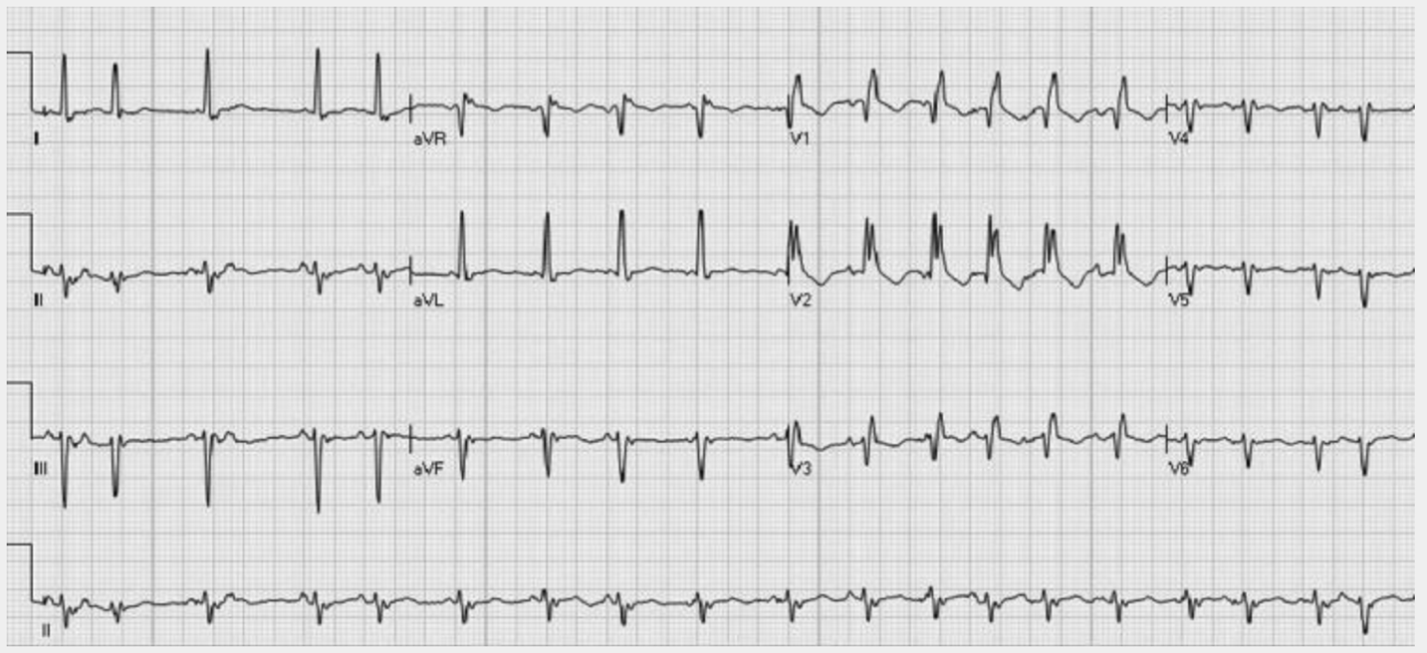

Which of the following abnormalities is demonstrated on this patient’s ECG?

- Atrial fibrillation
- Atrial tachycardia
- Multifocal atrial tachycardia
- Sinus tachycardia

- A 70-year-old man is evaluated for recently diagnosed paroxysmal atrial fibrillation that is mildly symptomatic. Medical history is significant for hypertension and previous stroke. Medications are rivaroxaban and metoprolol. He has experienced no episodes of bleeding on anticoagulation therapy.

On physical examination, blood pressure is 128/74 mm Hg and pulse rate is 72/min and regular. The remainder of the examination is unremarkable.

An echocardiogram reveals an enlarged left atrium and normal left ventricle. Forty-eight–hour ambulatory ECG monitoring shows atrial fibrillation prevalence of 10% with a controlled ventricular rate less than 90/min and no other abnormalities.
Which of the following is the most appropriate treatment?

- Left atrial appendage occlusion
- Pacemaker implantation
- Rhythm control
- Switch rivaroxaban to warfarin
- No additional therapy

- A 73-year-old man is evaluated during a follow-up visit for atrial fibrillation diagnosed 10 years ago. He is asymptomatic and has no activity limitations. Medications are rivaroxaban and metoprolol.

On physical examination, pulse rate is 72/min and irregular. All other physical examination findings are unremarkable.

A previous echocardiogram showed a severely enlarged left atrium and a normal left ventricle and ejection fraction. Ambulatory ECG data show atrial fibrillation with an average heart rate of 76/min (maximum, 128/min; minimum, 52/min).

Which of the following is the most appropriate management?

- Add amiodarone
- Catheter ablation
- Direct current cardioversion
- No change in therapy

- A 65-year-old woman is evaluated in the office after several visits to the emergency department for paroxysmal atrial fibrillation and acute heart failure. Medications are apixaban, metoprolol, furosemide, and losartan.

Vital signs are normal. Cardiopulmonary examination and the remainder of the physical examination are normal.

Results of laboratory studies show a normal serum thyroid-stimulating hormone level. An ECG shows sinus rhythm with a heart rate of 58/min. An echocardiogram reveals a left ventricular ejection fraction of 45%.

Which of the following is the most appropriate treatment?

- Atrioventricular node ablation with permanent pacemaker implantation
- Implantable cardioverter-defibrillator placement
- Left atrial appendage occlusion
- Rhythm control

- A 31-year-old woman is evaluated in the emergency department for shortness of breath, palpitations, and dizziness of 30 minutes’ duration. Medical history is remarkable for asthma. Her only medication is albuterol as needed.

On physical examination, she is afebrile, blood pressure is 110/65 mm Hg, and pulse rate is 174/min. The patient is alert, and her extremities are warm. A tachycardic, irregularly irregular rhythm is auscultated. There is no jugular venous distention or crackles on pulmonary examination.

The patient’s ECG is shown:

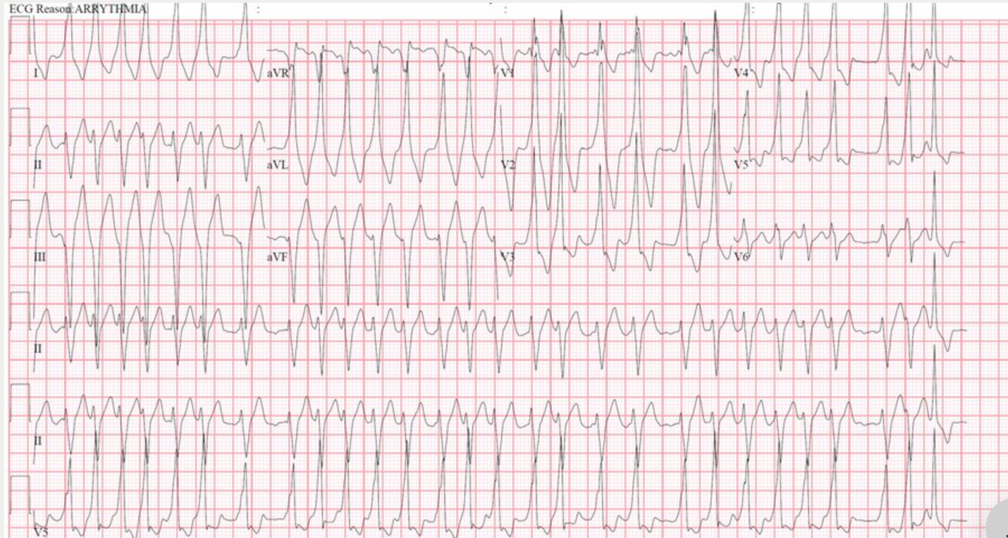

Which of the following is the most likely diagnosis?

- Atrial fibrillation
- Atrial flutter
- Multifocal atrial tachycardia
- Polymorphic ventricular tachycardia

