** If you use an underscore symbol like this: _ anywhere in your saved templates, you can move from underscore to underscore by just hitting F3**

- Open a patient chart.
  - Use ZZTEST, TEN if you’re worried about accidentally saving something to a real person’s chart

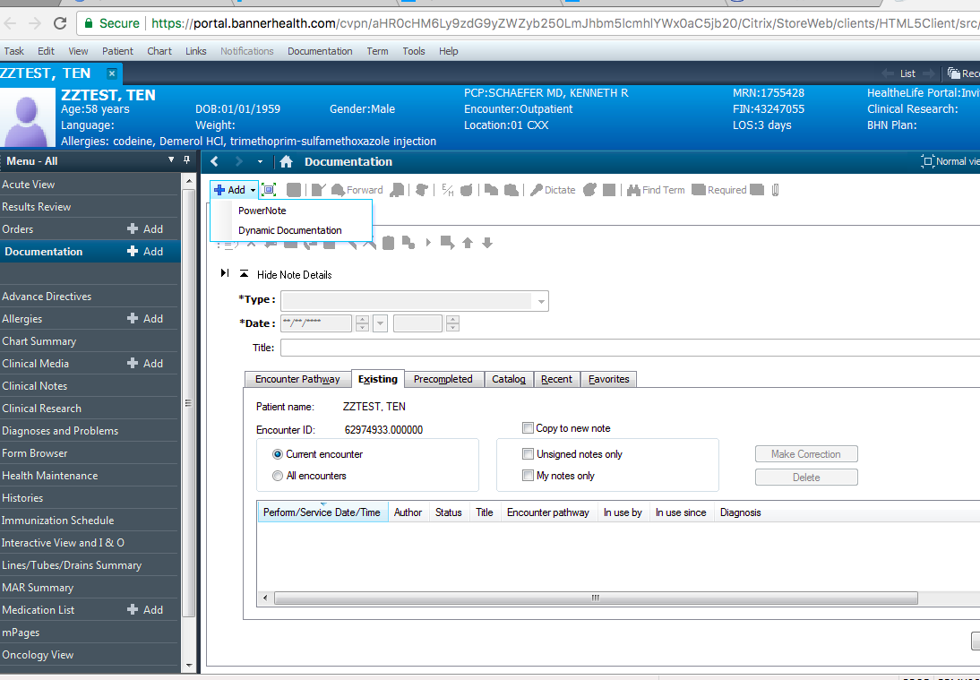

- Open up any note in PowerNote, Dynamic Documentation or Clinical Note
- Once in the note, click anywhere to start free texting
- Once you start typing, you will see a button in the toolbar above the note that says “Manage Auto Text” when you hover over it. Click it.

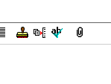

- Once in the auto text manager (DOT phrase manager), you can see your personal phrases or the public phrases that anyone can use

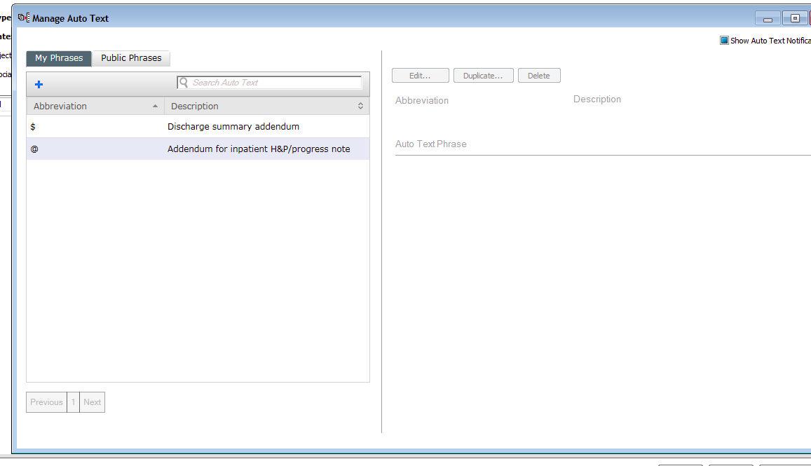

- Click the blue (+) sign under My Phrases to add a new phrase.

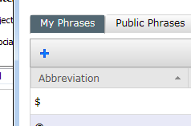

- Enter the abbreviation which you will type in to trigger the dot phrase popping up. (THIS IS CASE SENSITIVE).

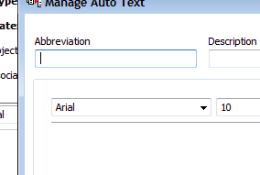

  - Some people like ..nameoftemplate
  - Some people like symbols that they don’t really use often in their notes (@, $, ^, etc).
  - I would avoid using the symbol #, becase we all use that a ton in our notes, and every time you type it, the dotphrase menu will show up.

- Title the dot phrase something that makes sense to you
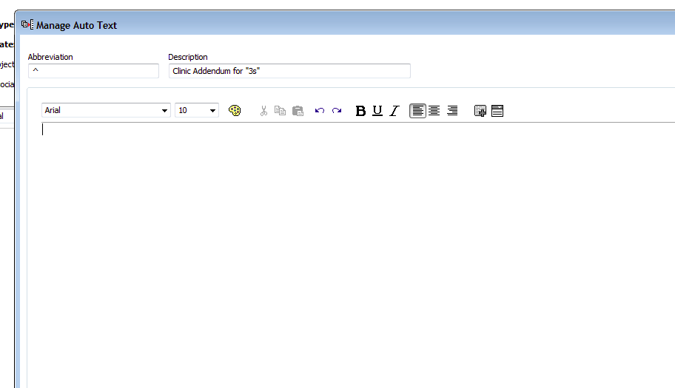

- Type what you want to automatically show up when you enter the dot phrase in the large box.
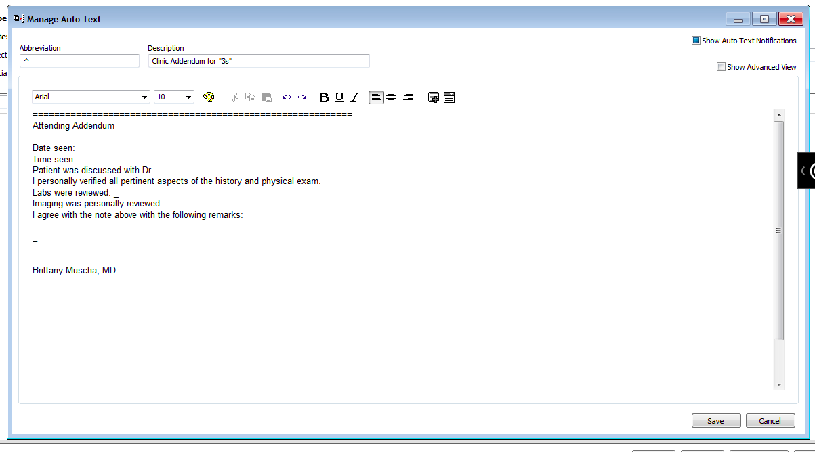

- You can customize your dot phrases with smart templates that automatically pull info from the chart into your note.
- Save your phrase. You can go back to edit it at any time if needed.

