ROC Curves

Diagnostic tests most often have values that are continuous (think troponin). A cutoff value has to be determined in order to see if the test is positive or negative. The cutoff value is determined by whether sensitivity, specificity or a combination of the two is most desired.
For example, if we want to virtually never miss diagnosing an MI with troponin, we would lower the cutoff (at the risk of getting too many false positives). Or, if we want to be sure a positive is real, we could raise the cutoff, increasing specificity (at the risk of missing some MI’s). The actual current cutoff used for troponin is a good compromise of sensitivity and specificity.
One way to look at a diagnostic test is by constructing an ROC curve. This graph looks at the tradeoff of sensitivity and specificity by plotting every test value in a given study. The y axis is sensitivity (sometimes called true positive rate) and the x axis is 1-specificity (sometimes called false positive rate). Each point represents the x and y values at a given cutoff value. As you raise the cutoff, you progress from the upper right corner to the lower left (sensitivity decreases and specificity increases). The points are connected to create a curve.
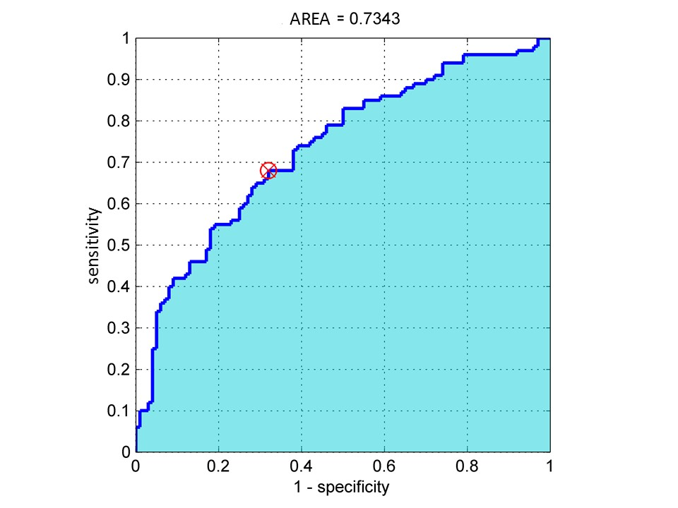
In the graph above, the curve reveals two main findings. One is the area under the curve (here 0.73), which is the fraction of the graph that is under the curve. To be a good test, this area should generally be at least 0.80 or 0.85. The second finding is that if we want the cutoff value that best balances sensitivity and specificity, we should look for the point that is closest to the upper left corner (where sensitivity and specificity are both 1.0). Here, the best cutoff is marked with an X. At this cutoff value, the sensitivity is about 0.68 and the specificity about 0.68 (1-specificity is 0.32).

