November 14, 2023, AHD MKSAP Questions and LOs

- A 65-year-old man is evaluated for a 2-day history of several episodes of chest discomfort and dyspnea occurring both at rest and with exertion. Today he presents with 3 hours of persistent, severe central chest pressure.

On physical examination, blood pressure is 155/90 mm Hg, pulse rate is 90/min, respiration rate is 20/min, and oxygen saturation is 93% with the patient breathing ambient air. BMI is 29. An S4 is present, but the remainder of the cardiac examination is normal.

High-sensitivity cardiac troponin level is elevated (>99th percentile upper reference limit.)

An ECG is shown:

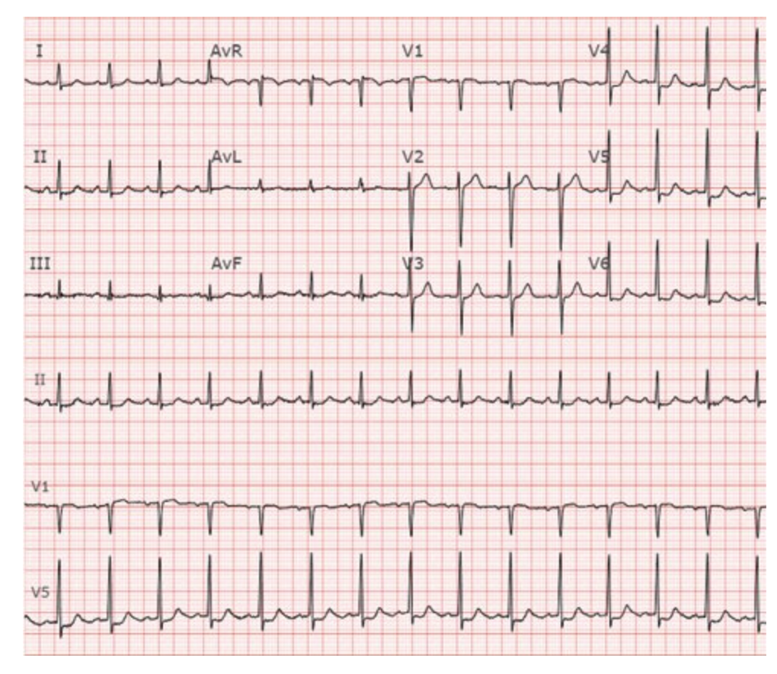
He is given aspirin, clopidogrel, intravenous unfractionated heparin, and a nitroglycerin infusion. His chest pain initially improves but returns despite nitroglycerin and infusion and morphine.

Which of the following is the most appropriate management?

- Echocardiography
- Eplerenone
- Oxygen per nasal cannula
- Urgent coronary angiography

- A 65-year-old woman is evaluated in the office after visits to the emergency room for paroxysmal atrial fibrillation and acute heart failure. Medications are apixaban, metoprolol, furosemide, and losartan.

Vital signs are normal. Cardiopulmonary examination and the remainder of the physical examination are normal.

Results of laboratory studies show a normal serum thyroid-stimulating hormone level.

An ECG shows sinus rhythm with a heart rate of 58/min. An echocardiogram reveals a left ventricular ejection fraction of 45%.

Which of the following is the most appropriate treatment?

- Atrioventricular node ablation with permanent pacemaker implantation
- Implantable cardioverter-defibrillator placement
- Left atrial appendage occlusion
- Rhythm control

- A 75-year-old man with ESRD on HD is admitted to the hospital after a mechanical ground level fall resulted in an intertrochanteric femur fracture. He has a history of CAD s/p bypass 10 years ago and chronic heart failure on GDMT with an EF of 45% 3 months ago. He has type 2 DM and is taking insulin therapy. The orthopedic surgery service would like you to assess his cardiac risk prior to surgery and recommend a plan.

Currently, the patient has a BP of 155/80 mm Hg, HR 80, RR 22, and he is afebrile. He has significant pain with any movement of the limb. An EKG shows evidence of an old inferior infarct.

Which of the following is the most appropriate next step?

- Proceed to surgery
- Hold surgery and order echocardiogram
- Hold surgery and perform a vasodilator stress test
- Consult cardiology

Write the answers to the following learning objectives. Please take the time to research your answers.

- Define severe aortic stenosis by valve area and gradient. Describe pseudo- aortic stenosis and how it is diagnosed.

- List several causes for acute and chronic aortic regurgitation.

- Describe the management of a patient who presents to the hospital in an acute heart failure exacerbation with signs of volume overload and who is adequately perfusing.

