January 9, 2024
AHD Objectives
Hyperkalemia
- Describe the laboratory evaluation that must be obtained to work up the hyperkalemic patient. (Comment on pseudohyperkalemia, EKG findings and sensitivity, and the required urine studies.)
- Describe the acute management of the hyperkalemic patient including steps to stabilize the myocardial membrane, shift potassium into the cells, and lower the total body potassium. Know the appropriate doses, methods of delivery, and contraindications to calcium gluconate, insulin and glucose, beta-agonists, and kayexalate.
- Know when to hospitalize and when to treat hyperkalemia.
Hyponatremia
- Define hyponatremia (mild, moderate, and severe), and specifically the time frame of acute versus chronic hyponatremia.
- Describe the signs and symptoms of hyponatremia from subtle to severe.
- Describe the initial management of a patient with severe, symptomatic hyponatremia.
- Give the differential diagnosis for the following:
  - Hypertonic hyponatremia
  - Isotonic hyponatremia
  - Hypotonic hyponatremia (What is the serum osmolality threshold for this?)
- What is the first step in determining the etiology of a HYPOTONIC hyponatremia?
- Describe the urine studies and lab findings (urine osmolality and/or urine sodium) that can help distinguish between the different causes of HYPOTONIC hyponatremia. Know the management of each of these diagnoses.
- Describe how to determine the free water deficit in a patient with hypernatremia and how to manage the patient to avoid osmotic demyelination.
Urinalysis cases- Dr. Dahl
- Describe the appropriate urine specimen collection and storage in ambulatory patients and hospitalized patients with Foley catheters in order to accurately interpret the urinalysis.
- List the possible causes of urine that is cloudy, orange, brown, or red.
- Complete the urinalysis table: 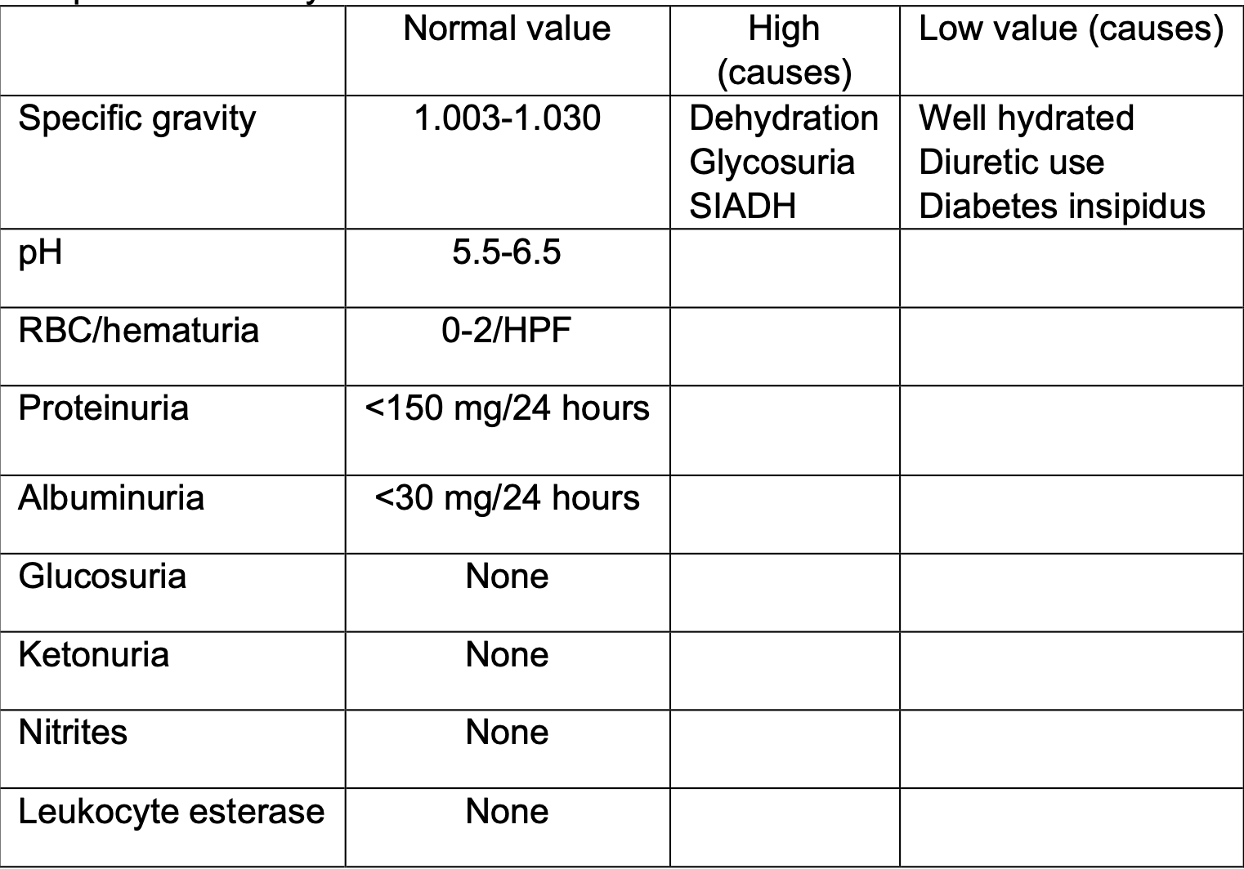
- Describe the conditions associated with the following urine casts: Hyaline, Erythrocyte, Leukocyte, Epithelial, Granular, Fatty.

