Obtaining Consent In Person

You can access iMed Consent under the tools menu:
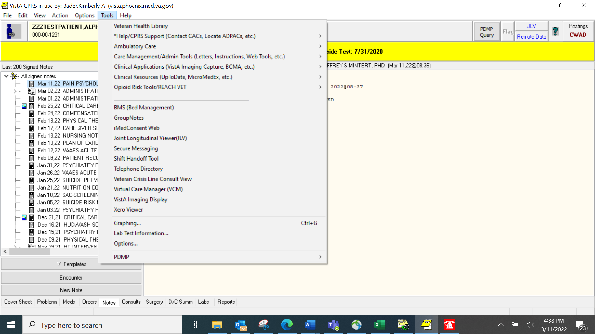

This tool will open in an internet window, and you log in using you PIV card. Once in the iMed tool, you can search for the type of consent in the search button:

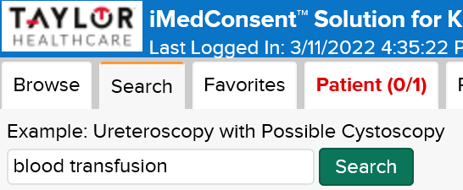

In the bottom right corner, you click the start button to start the consent process. Right above this you can add the consent title to your favorites for future use:
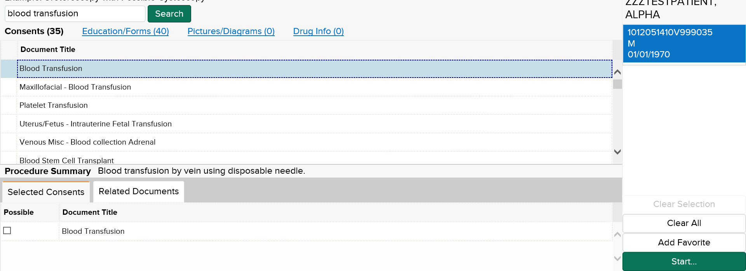
In the future the consent title will show up under your favorites tab:
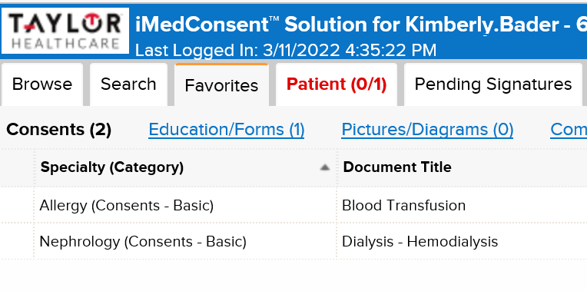
Once you click the start button, the consent will open, and you input the necessary information. The consent will prompt you on procedure specific risks to discuss with the patient.
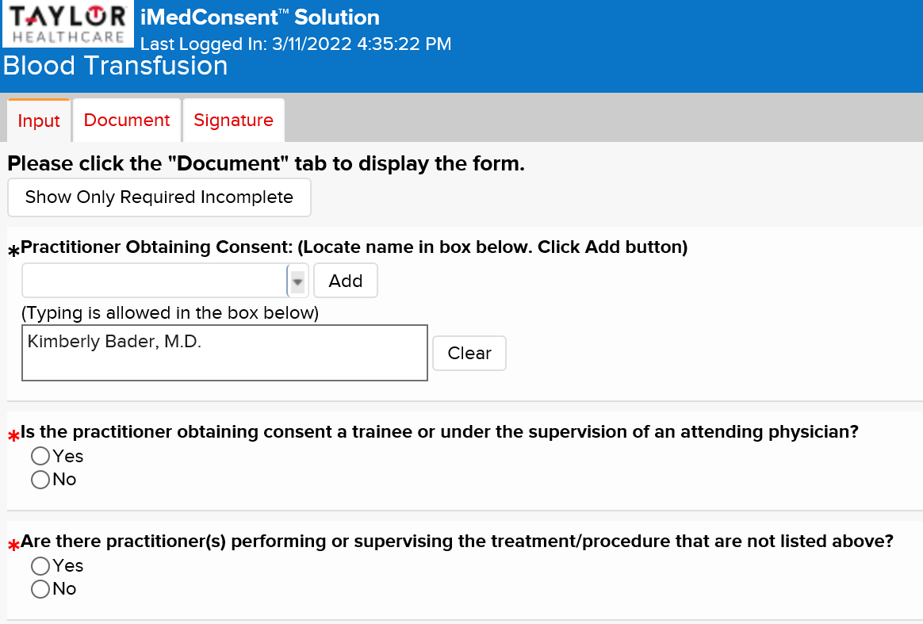
When you are done with the input tab, click on the document tab to generate the document:
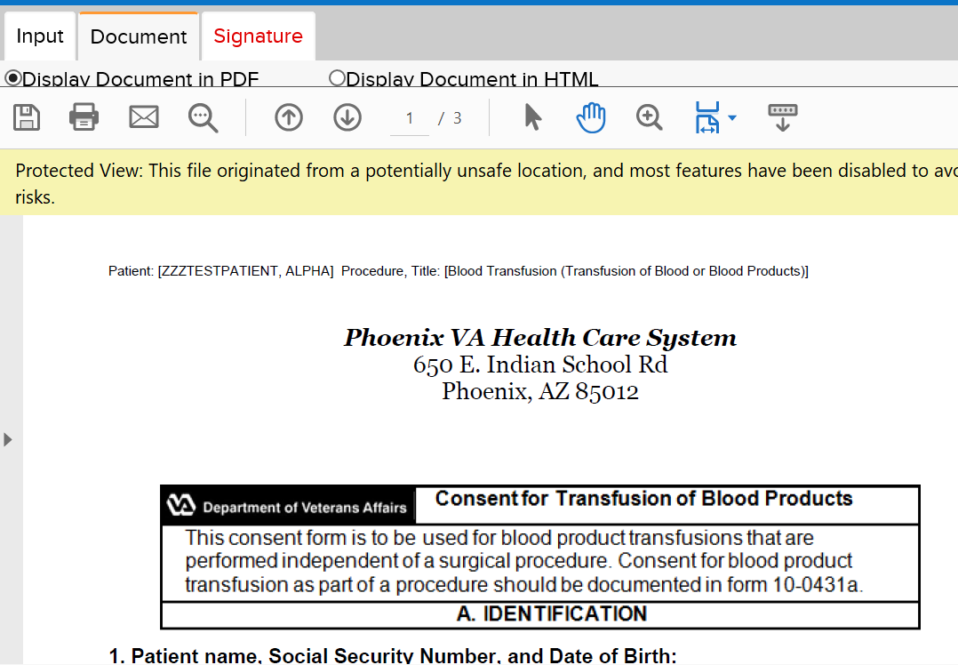

Finally, click on the signature tab and both you and the patient or surrogate sign the form.
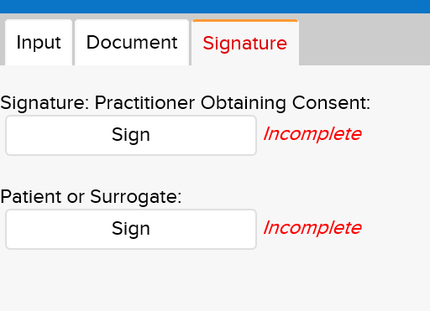

If the signature pad on your mobile workstation doesn’t work, the screens are touchscreens so you and the patient can sign on the screen with your finger.

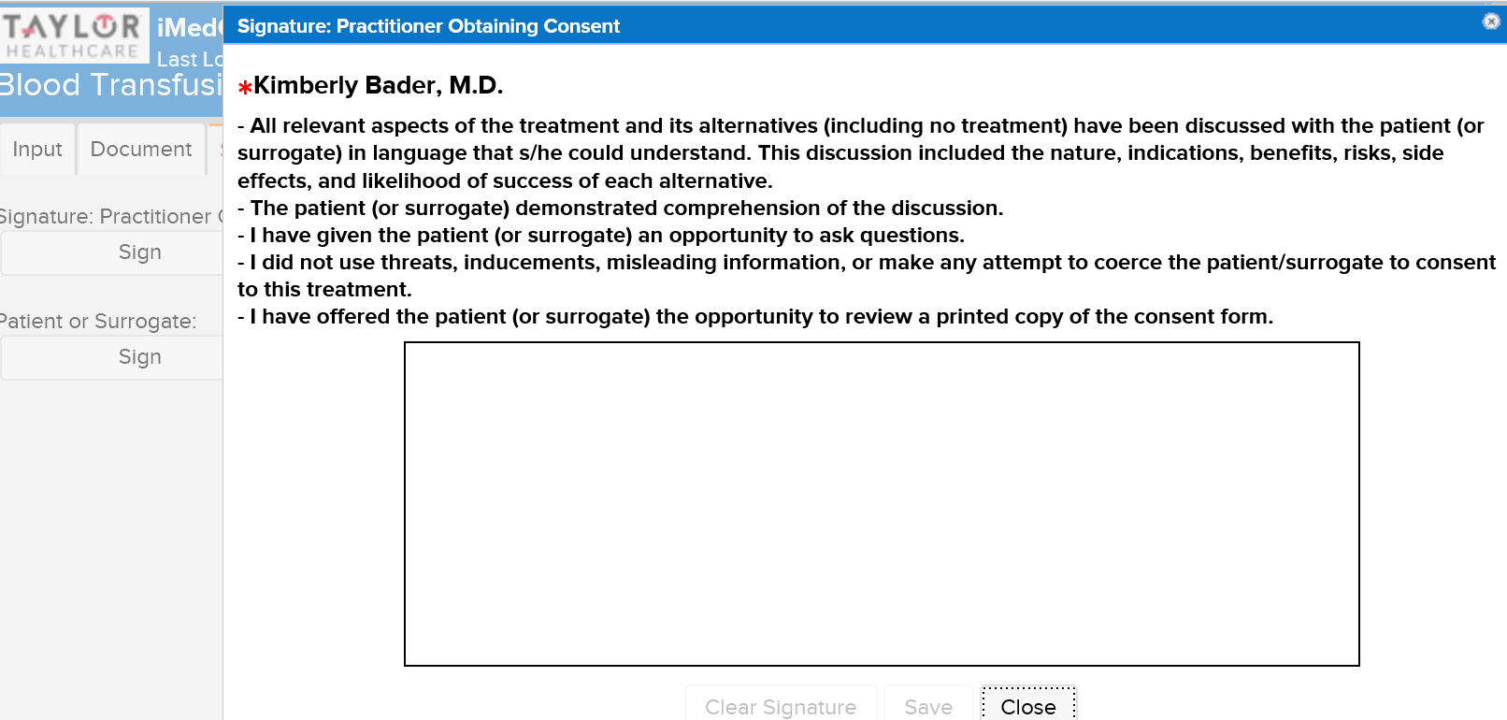

Once both parties have signed the consent you generate the document in the bottom right hand:
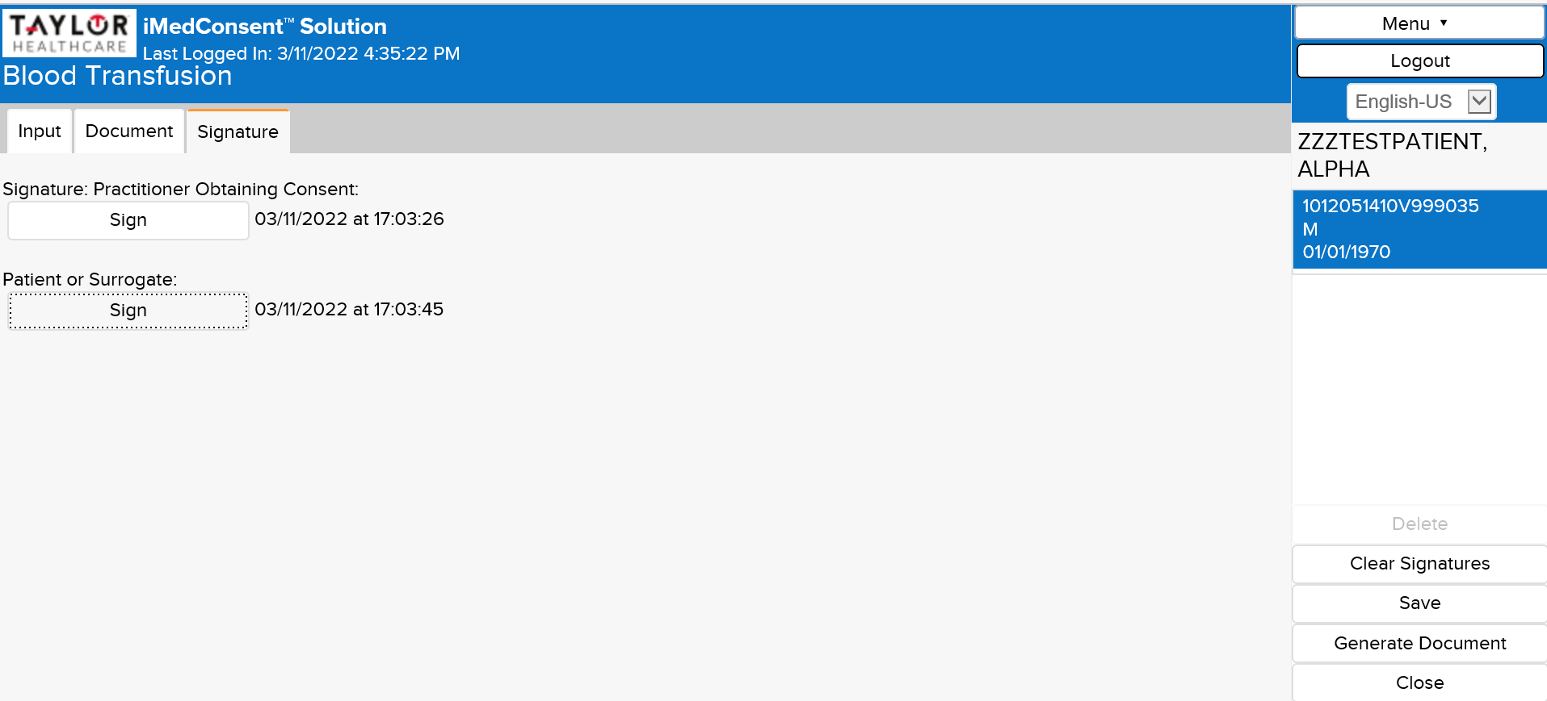

The consent will generate, and you press the close button in the bottom right:
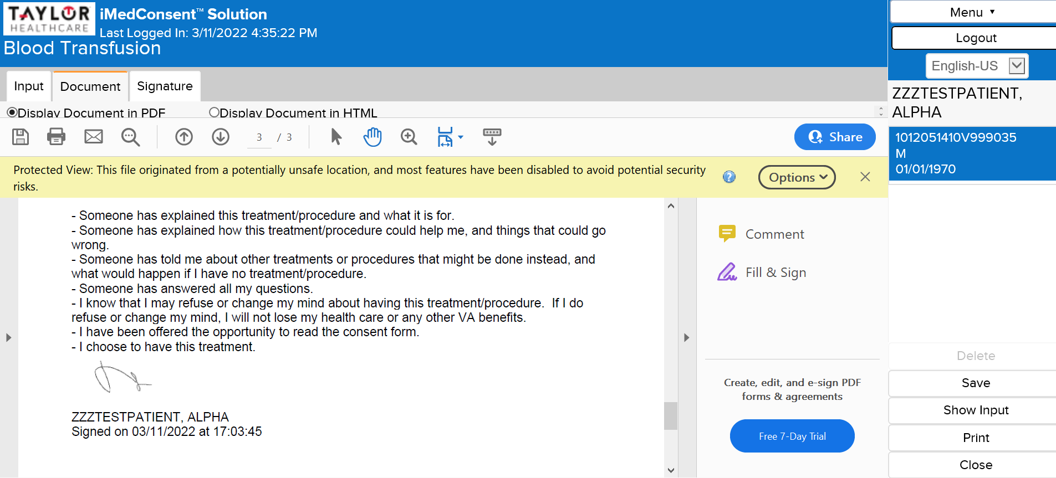

When you refresh the chart in CPRS your signed consent will show up:
