CPRS NOTE RETRACTION
- If you enter a note in error on a patient or sign a note before you have edited it by mistake, you can request to have the note retracted.
- Retracted notes do not leave the chart, but they will no longer be able to be read by standard CPRS users.
- Under the Tools menu on the Notes tab click on Help / CPRS support
- Then click on CPRS Note Retraction
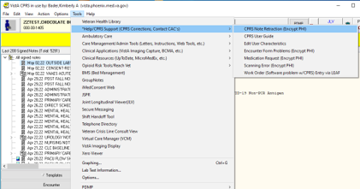
- This will open an email to the Medical Records department. Enter the requested information about the note you want retracted.

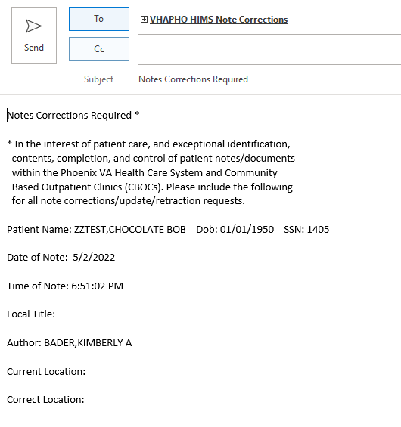
- Place an addendum on the note you want retracted saying the note was entered in error / signed in error to make it clear to the Medical Records department that this is the note to be retracted.
- You can then enter the correct information in a new note.

