Disorders of the Gallbladder and Bile Ducts

Gallstones

Key Point
- Asymptomatic gallstones discovered incidentally do not require cholecystectomy except in the setting of a high risk for gallbladder cancer (gallstones >3 cm, porcelain gallbladder, or gallbladder polyps >1 cm).
Gallstones are characterized as cholesterol stones or pigment stones. Cholesterol stones result from supersaturation of bile with cholesterol; they account for approximately 75% of gallstones in the United States. Risk factors for cholesterol stones include the following:
- Older age
- Female sex (twice as likely in women as in men)
- Native American ethnicity
- Western diet
- Pregnancy
- Rapid weight loss
- Obesity
- Total parenteral nutrition
- Estrogen supplementation
Predisposing factors for pigment stones include the following:
- Chronic hemolysis
- Ineffective erythropoiesis
- Crohn disease
- Cirrhosis
- Biliary stasis
- Bacterial biliary infections
Gallstones are commonly discovered with abdominal ultrasonography (Figure: Right-Upper-Quadrant Ultrasound Showing Gallstones) and CT performed for unrelated reasons.
Right-Upper-Quadrant Ultrasound Showing Gallstones
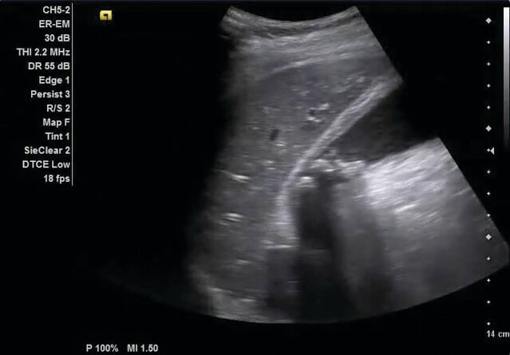
Ultrasound shows the liver (left) and the gallbladder in long axis with multiple stones present. The stones appear hyperechoic (white) with shadowing artifact posteriorly, consistent with cholelithiasis. The lumen of a normal gallbladder should appear anechoic (black). It is important to scan through the gallbladder to ensure that the entire lumen is visualized before determining whether stones are absent. An indeterminate study would occur if the gallbladder cannot be completely visualized, usually because of underdistention secondary to lack of fasting.

Incidental gallstones are typically asymptomatic, and prophylactic cholecystectomy is generally not recommended. Cholecystectomy is indicated in asymptomatic patients with characteristics posing a high risk for gallbladder cancer: gallstones larger than 3 cm, porcelain gallbladder (calcification of the gallbladder wall), or gallbladder polyps larger than 1 cm.

Biliary Colic

Key Points
- Biliary colic pain is typically acute, lasts 30 minutes to 6 hours, is severe and steady, and is located in the right upper quadrant or epigastrium.
- Patients with typical biliary colic symptoms and gallstones on imaging should undergo cholecystectomy.
Biliary colic results from contraction of the gallbladder in the presence of an obstructed cystic duct, usually by a gallstone. Pain is typically of acute onset, lasts 30 minutes to 6 hours, is severe and steady, and is located in the right upper quadrant or epigastrium. Pain may radiate to the right shoulder and is associated with nausea, vomiting, and diaphoresis. Symptoms may be precipitated by meals, which cause gallbladder contraction. Constant, unremitting abdominal pain is not usually associated with biliary colic.
Patients with typical biliary colic symptoms and gallstones on imaging should undergo cholecystectomy because of an increased risk for future complications, including choledocholithiasis, cholangitis, and pancreatitis.

Acute Cholecystitis

Key Points
- Cholecystitis can be diagnosed by suggestive clinical findings and ultrasound showing gallbladder-wall thickening or edema and sonographic Murphy sign.
- Treatment of acute cholecystitis includes analgesia, intravenous antibiotics with gram-negative and anaerobic coverage, and cholecystectomy during initial hospitalization; percutaneous cholecystostomy tube drainage or endoscopic drainage can be pursued in patients with high surgical risk.
Acute cholecystitis is caused by cystic duct obstruction and gallbladder inflammation, often accompanied by gallbladder infection. Patients present with severe right-upper-quadrant pain or epigastric pain lasting longer than 6 hours, as well as fever and tenderness in the right upper quadrant. A positive Murphy sign (inspiratory arrest during deep inspiration upon palpation of the gallbladder fossa) may be present.
Laboratory studies may show leukocytosis; liver chemistries are often normal or minimally elevated unless complications, such as common bile duct obstruction or cholangitis, are present. Acute cholecystitis is suggested by ultrasound showing gallbladder wall thickening and/or edema and a sonographic Murphy sign (arrest of respiration with compression by the ultrasonography probe) (Figure: Gallbladder Ultrasound Showing Acute Cholecystitis). Lack of gallbladder filling on hepatobiliary iminodiacetic acid (HIDA) scanning supports this diagnosis; this test is appropriate in the setting of a high clinical likelihood of acute cholecystitis but a negative or indeterminate ultrasound finding.
Gallbladder Ultrasound Showing Acute Cholecystitis
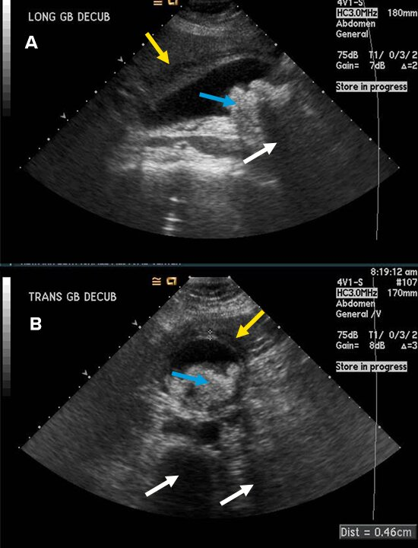
Ultrasound of the gallbladder shows classic features of acute cholecystitis in longitudinal (A) and transverse (B) planes. Pericholecystic fluid (yellow arrows) and acoustic shadowing (white arrows) from the gallstones (blue arrows) can be seen.

Treatment includes analgesia, intravenous antibiotics with gram-negative and anaerobic coverage, and cholecystectomy. Most patients should undergo cholecystectomy during initial hospitalization. Emergency surgery is necessary for suspected gallbladder perforation or emphysematous cholecystitis (infection of the gallbladder wall with gas-forming organisms, such as Clostridium perfringens). Most patients should undergo cholecystectomy during initial hospitalization. Patients with high surgical risk who respond to antibiotics can be reassessed later to determine whether their surgical risk has decreased. In patients who are poor surgical candidates and do not respond to antibiotics, percutaneous cholecystostomy tube drainage or endoscopic drainage can be pursued.

Acalculous Cholecystitis

Key Points
- Acalculous cholecystitis typically occurs in critically ill patients and results from gallbladder ischemia; alert patients present with pain whereas sedated or mechanically ventilated patients may present with leukocytosis, jaundice, or sepsis.
- Treatment of acalculous cholecystitis includes intravenous antibiotics to cover enteric bacteria and cholecystectomy; a percutaneous cholecystostomy tube may be needed for unstable patients or poor surgical candidates.
Acalculous cholecystitis typically occurs in critically ill patients and results from gallbladder ischemia, which can be complicated by enteric bacterial infection. Risk factors include the following:
- Cardiac surgery
- Sepsis
- Burns
- Vasculitis
Alert patients typically present with pain, similar to that seen in cholecystitis. However, in sedated or mechanically ventilated patients, it may present with leukocytosis, jaundice, or sepsis. The diagnosis is made by ultrasound showing pericholecystic fluid, gallbladder distention, and pneumatosis without stones (Figure: Gallbladder Ultrasound Consistent With Acalculous Cholecystitis).
Gallbladder Ultrasound Consistent With Acalculous Cholecystitis
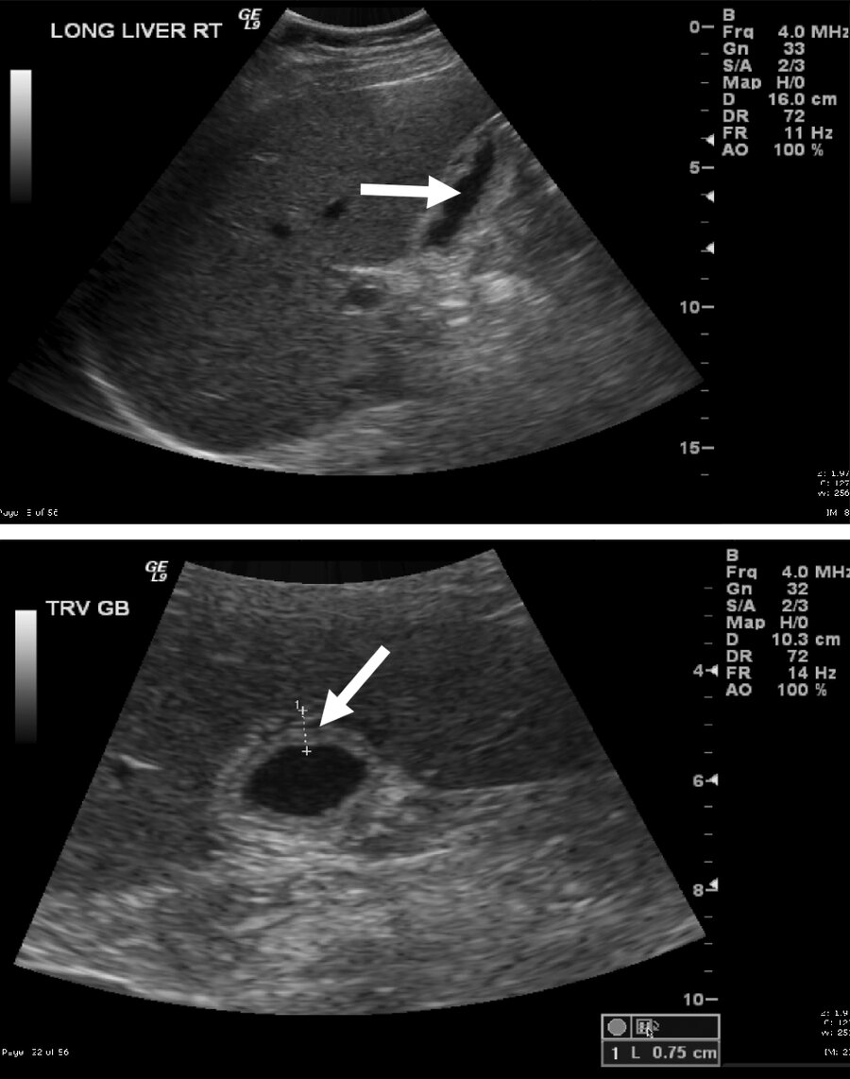
Ultrasound of gallbladder consistent with acalculous cholecystitis shows absence of gallstones in the lumen (top arrow), pericholecystic fluid (bottom arrow), and a thickened gallbladder wall.

Treatment entails intravenous antibiotics to cover enteric bacteria and cholecystectomy. A percutaneous cholecystostomy tube may be needed for unstable patients or poor surgical candidates. Endoscopic gallbladder drainage can be considered. The mortality rate for untreated acalculous cholecystitis is as high as 50%.

Functional Gallbladder Disorder
Functional gallbladder disorder should be considered in patients with biliary pain without gallstones or structural pathology. Other causes of upper abdominal discomfort, including peptic ulcer disease and angina, should be considered. A gallbladder ejection fraction less than 40% as measured by cholecystokinin-stimulated cholescintigraphy supports the diagnosis but may not predict response to cholecystectomy.
Reassurance and antispasmodic agents may be of benefit. If no other cause of pain is found, pain recurs, and the gallbladder ejection fraction is less than 40%, then cholecystectomy can be considered.

Common Bile Duct Stones and Cholangitis

Key Points
- Symptoms of cholangitis include fever, jaundice, and right-upper-quadrant pain.
- Endoscopic retrograde cholangiopancreatography is the preferred method for relieving obstruction caused by a common bile duct stone.
- Cholangitis is potentially life-threatening; antibiotics targeting gram-negative Enterobacteriaceae should be administered immediately, and identified common bile duct stones should be removed urgently.
Common bile duct stones are a leading cause of obstructive jaundice and pancreatitis. Although 20% of common duct stones pass spontaneously and less than 50% of patients develop symptoms, stone extraction should be offered to most patients. Symptoms of common bile duct stones include jaundice and abdominal pain. Common duct stones may be visualized by transabdominal ultrasonography. In the absence of visualization, an elevated serum bilirubin level and dilated common duct on ultrasonography suggest the diagnosis. Endoscopic retrograde cholangiopancreatography (ERCP) is the preferred method for stone extraction and should be performed in patients with a high likelihood of choledocholithiasis (Figure: ERCP Showing Choledocholithiasis). In patients who are suspected of having common duct stones but have indeterminate findings on ultrasonography, magnetic resonance cholangiopancreatography (MRCP) or endoscopic ultrasonography should be performed to avoid ERCP risks. Cholecystectomy should be performed within 2 weeks of stone extraction.
ERCP Showing Choledocholithiasis
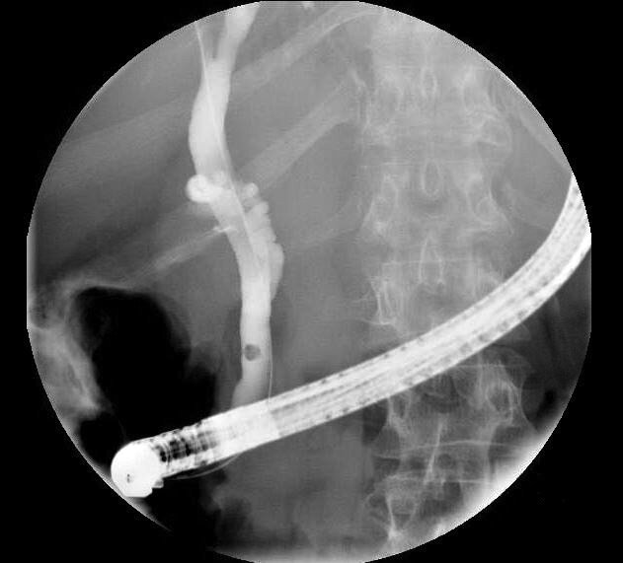
Choledocholithiasis is seen on endoscopic retrograde cholangiopancreatography (ERCP), which shows an approximately 5-mm round opacity in the distal common bile duct consistent with a stone.

Cholangitis is infection of the biliary tree, usually in the setting of biliary stasis or obstruction. Symptoms include fever, jaundice, and right-upper-quadrant pain (Charcot triad). Patients with cholangitis present with leukocytosis and elevated serum direct bilirubin, alkaline phosphatase, and gamma-glutamyl transpeptidase levels. In more severe cases, altered mental status and septic shock may also occur; this is referred to as the Reynolds pentad and occurs in only 3.5% to 5% of patients. Cholangitis is potentially life-threatening; antibiotics targeting gram-negative Enterobacteriaceae should be administered immediately. Common bile duct stones should be removed urgently with ERCP in patients with cholangitis, after which elective cholecystectomy should be performed during initial hospitalization to reduce the risk for complications. In patients who are not surgical candidates, endoscopic sphincterotomy can facilitate passage of additional common bile duct stones.

