Managing Orders by Location

Placing Inpatient Orders on Current Outpatients
- Look at the current listed location of the patient. If this is anything other than an inpatient unit then the default location for new orders being placed is the outpatient location. Orders placed here will disappear when the patient is admitted.

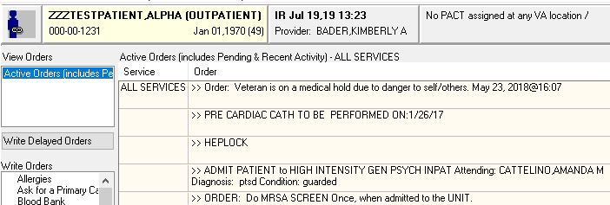

- If you are the primary service admitting the patient, you can start the delayed admission orders by clicking on “Write Delayed Orders.”

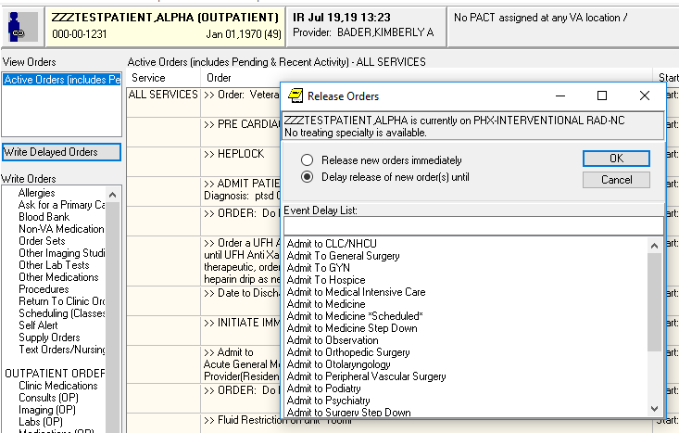

- Orders entered under delayed orders will become active upon admission.
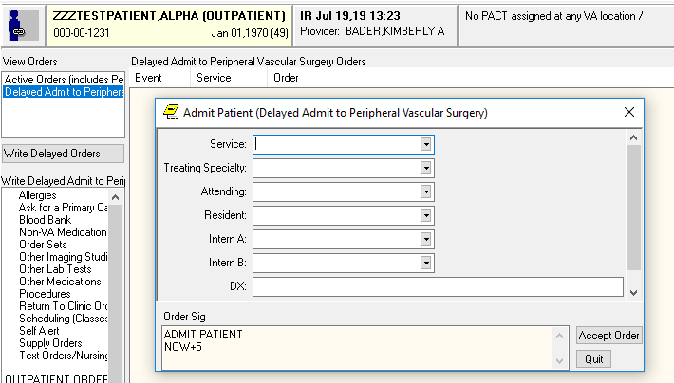

- If another service is admitting the patient, then look for the delayed orders tab and click on this tab to place orders that will be active once the patient is admitted. If there isn’t a delayed orders tab yet, then call the primary admitting team.

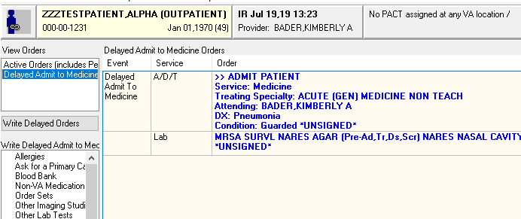

Managing Orders on Patients Going to the OR

- When inpatients are in the OR, they will still appear to have active orders, but these orders will all disappear when the patients return to the floor.

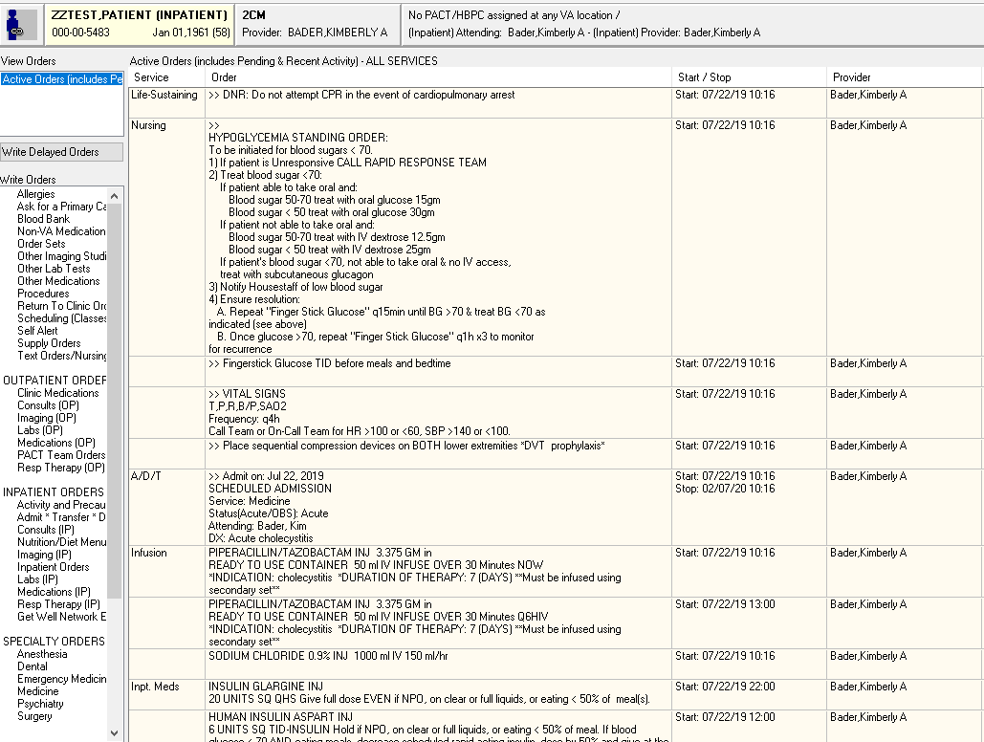

- All orders (except for code status, labs, radiology and consults) need to be copied to a new set of delayed orders so the patient will have active orders when they finish in the OR. Since the patient is still currently listed as an inpatient you click “Ok” to override the warning message and write delayed orders to admit the patient back to the same service.
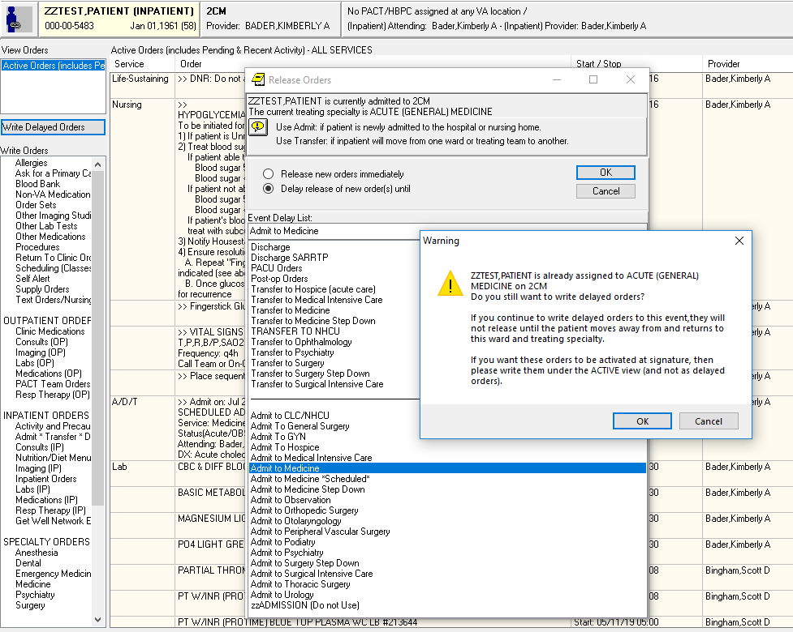
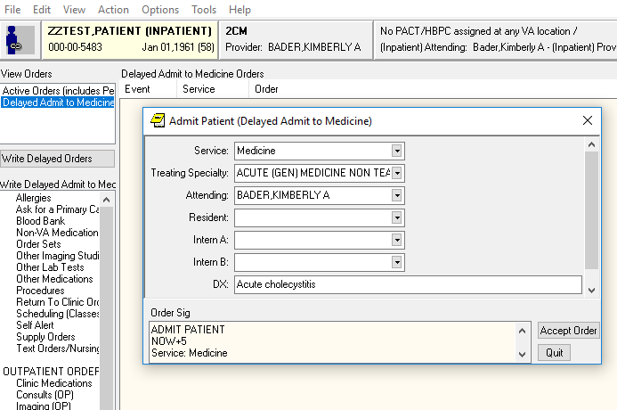

A menu will open with the current orders. You can choose which orders to copy over to the delayed orders by clicking CTRL and then left clicking all needed orders. Click ok to accept these copies.
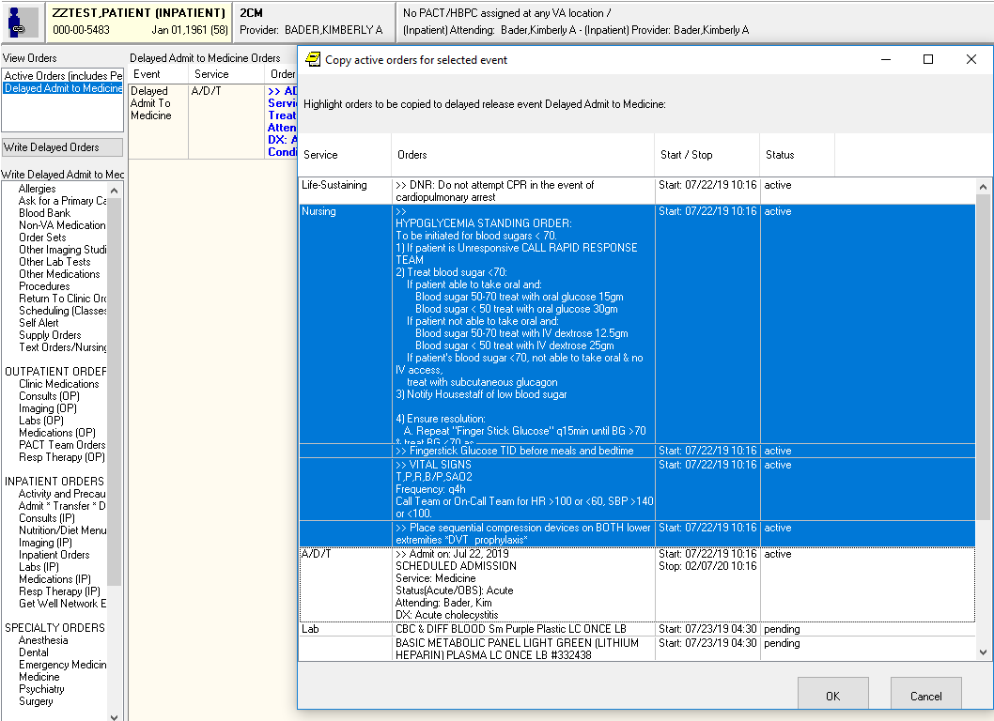

You can also copy orders directly from the active orders into delayed orders. Click CTRL and then left click on the desired orders. Then right click the selected orders and click on “Copy to New Order.” Choose “Delay release of copied orders” and chose your desired admission location. Your selected orders will copy to the delayed orders.
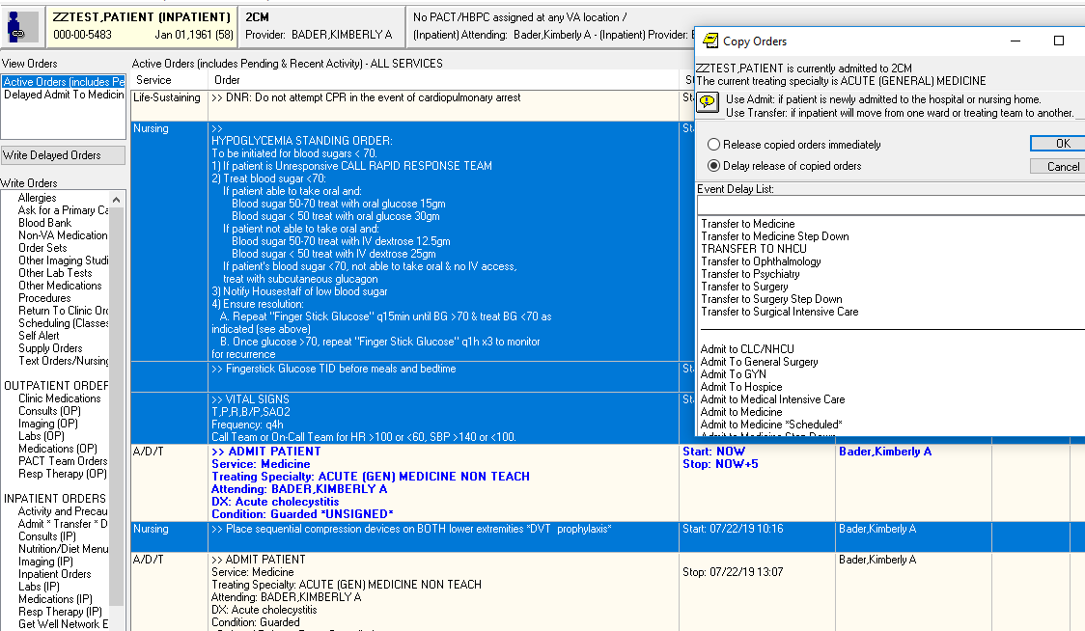
Managing Orders on Patients Transferring Units
- Patients transferring units (e.g. floor to step-down) or service and unit (Psychiatry floor to Medicine telemetry) will need delayed transfer orders entered. You can copy over pertinent orders as shown above.
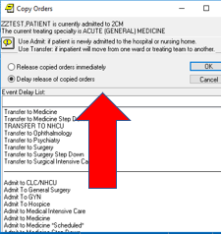

- If you need to place an urgent order on a patient that is waiting to transfer from one level of care to another, e.g. from the floor to the ICU, but hasn’t moved yet because they are waiting for a bed and there is a delay, then you will need to place the order in both the active and delayed orders.
