Radiology Tips
Comparing Films:
To compare films, first open the first film. On the top, click on View Settings and then 2x1 stack.
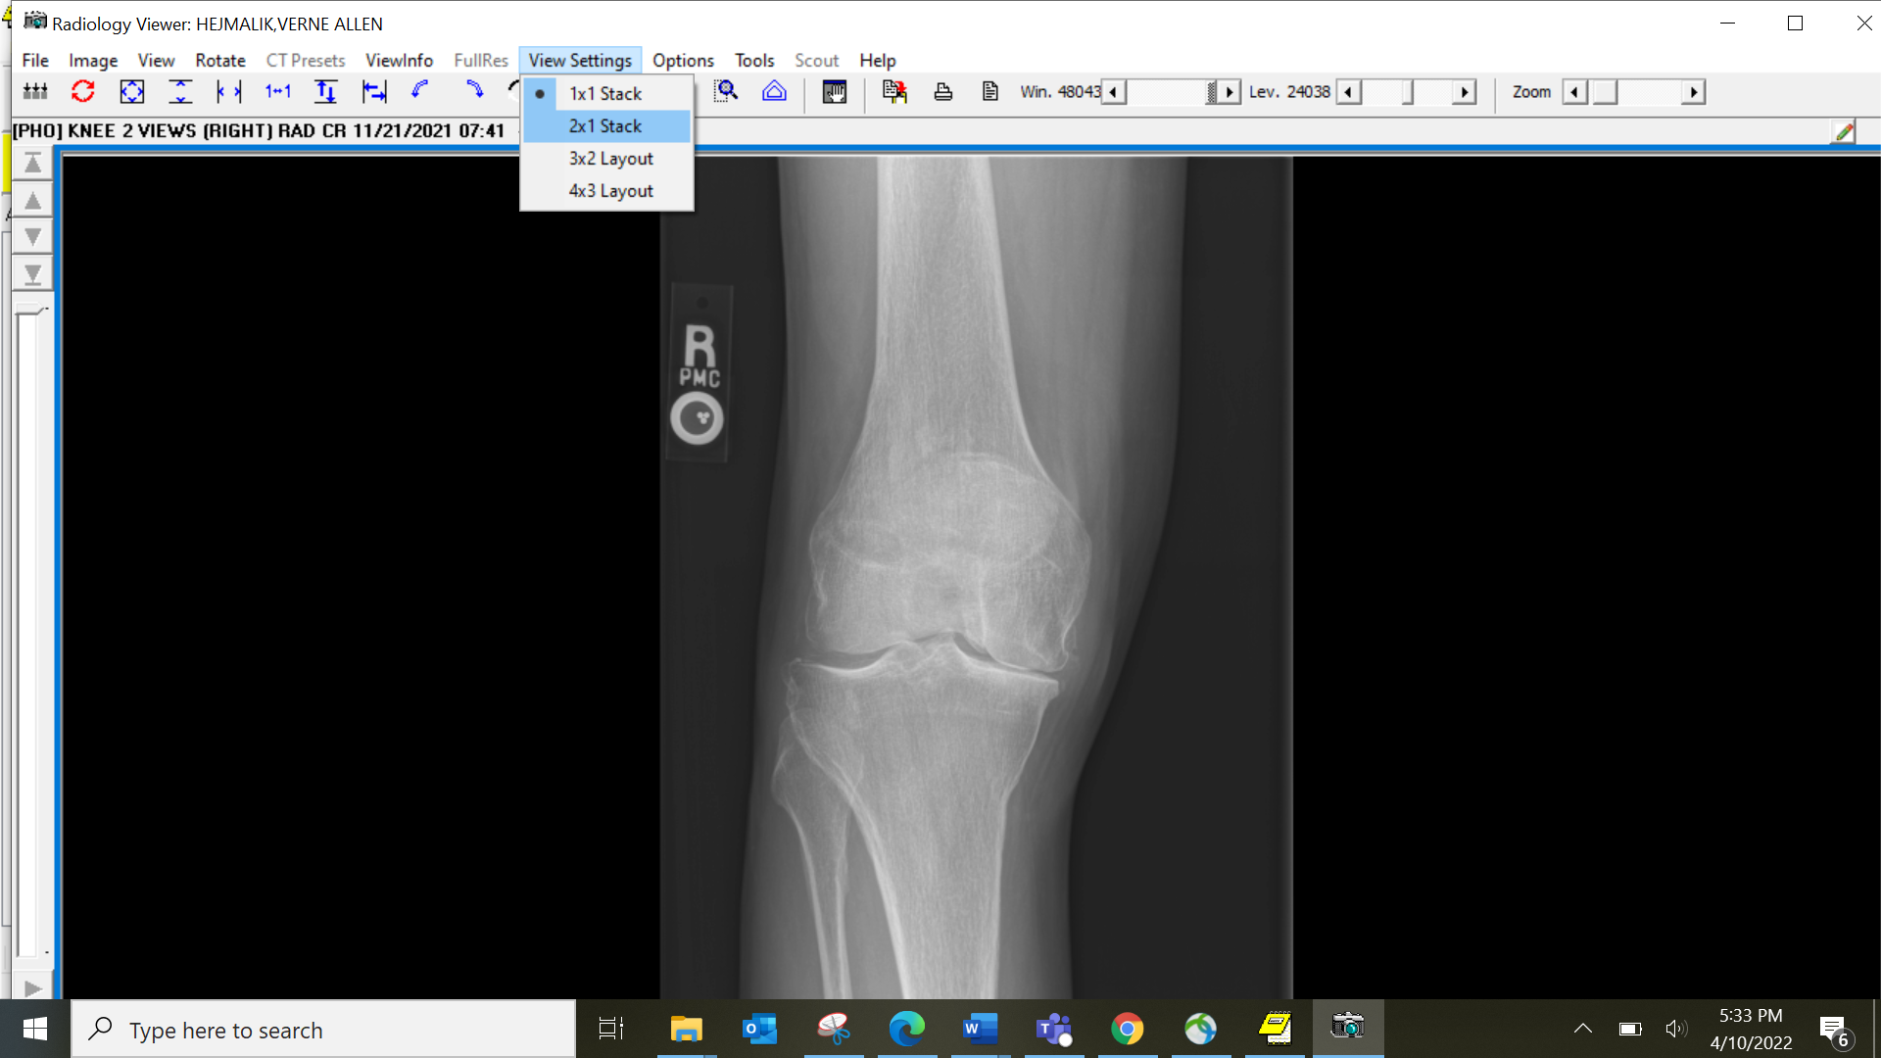
Your screen will now look like this:
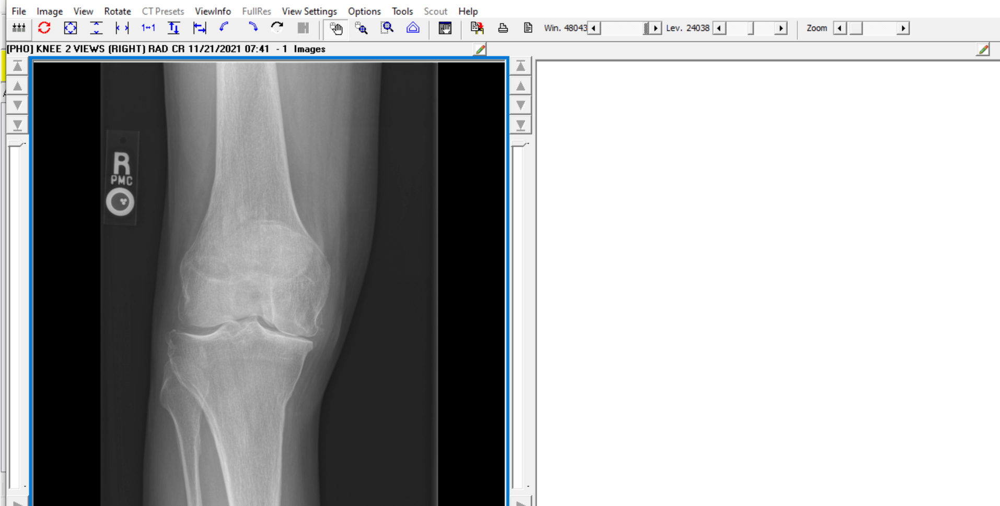

Next choose the second film you want to open for comparison from the list. If there is only 1 image, then right click on that image and select Open Image in 2nd Radiology Window. If there is more than 1 image in the selected set, then open the file by double clicking on it.
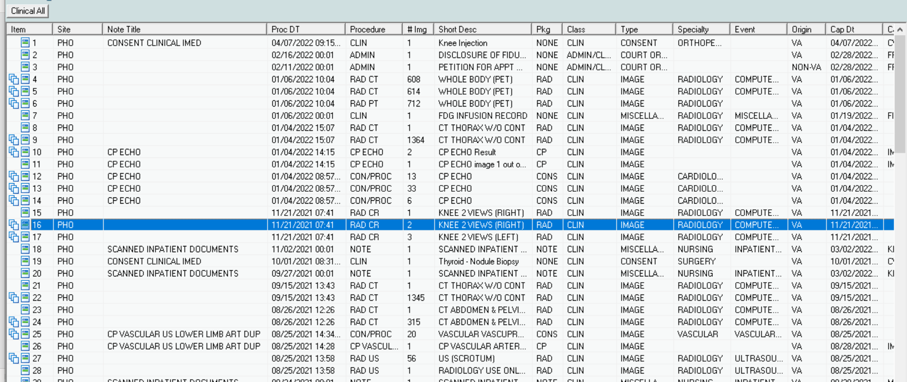

Then right click on the image you want to open and select Open Image in 2nd Radiology Window. This will allow you to compare the two films.
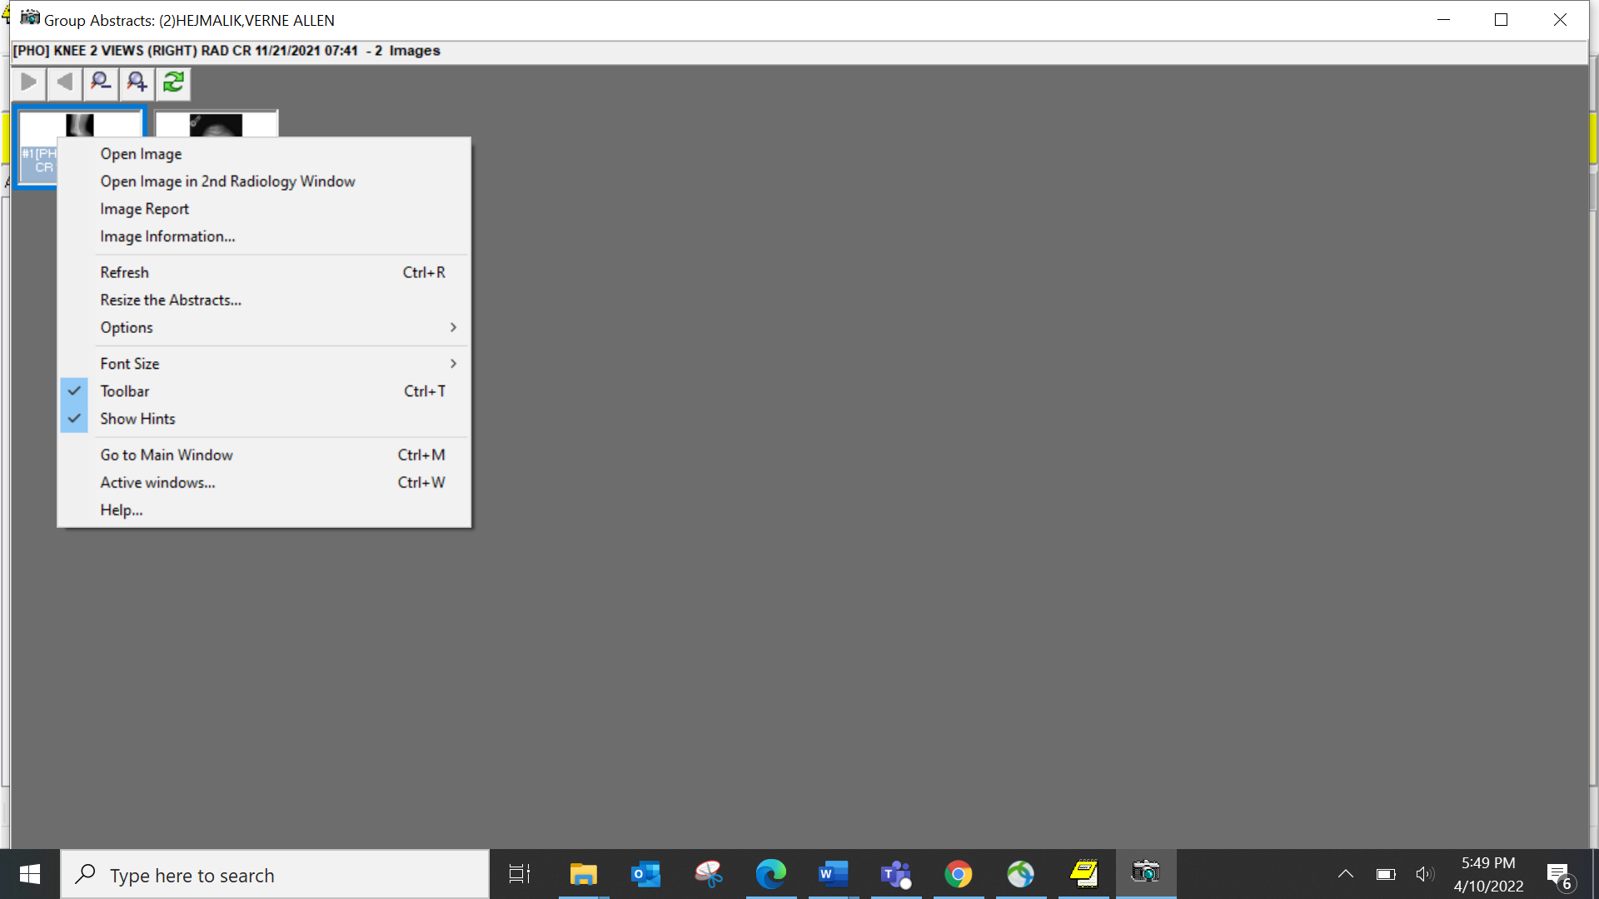
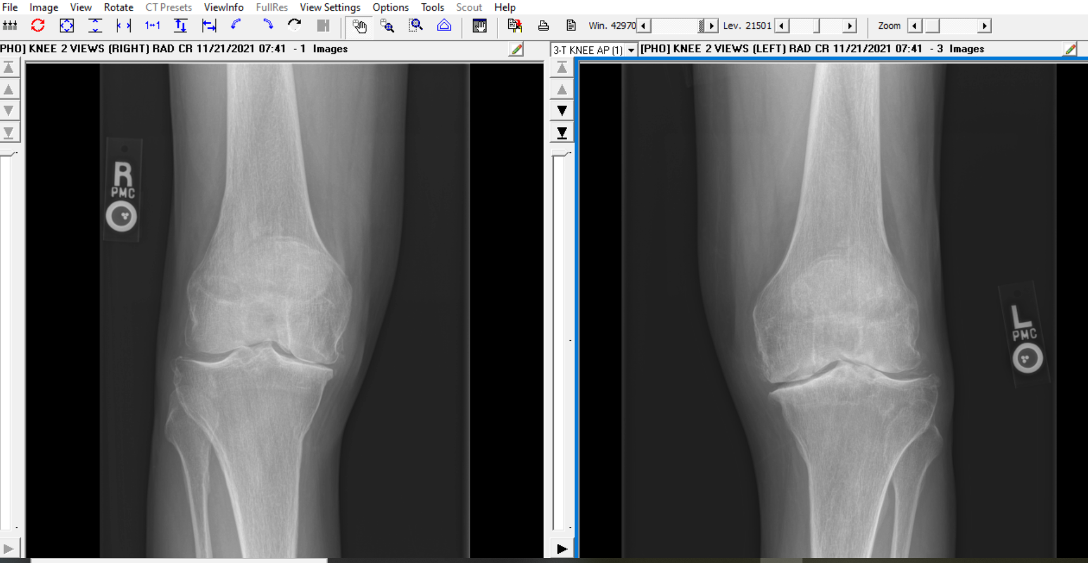
If there are multiple films in each series (like a CT scan), then both images will move together as you scan through the images.

Viewing Remote Images and Scanned Records:
Down at the bottom of the file list you will see the other VA Hospitals that you patient is registered at in red.

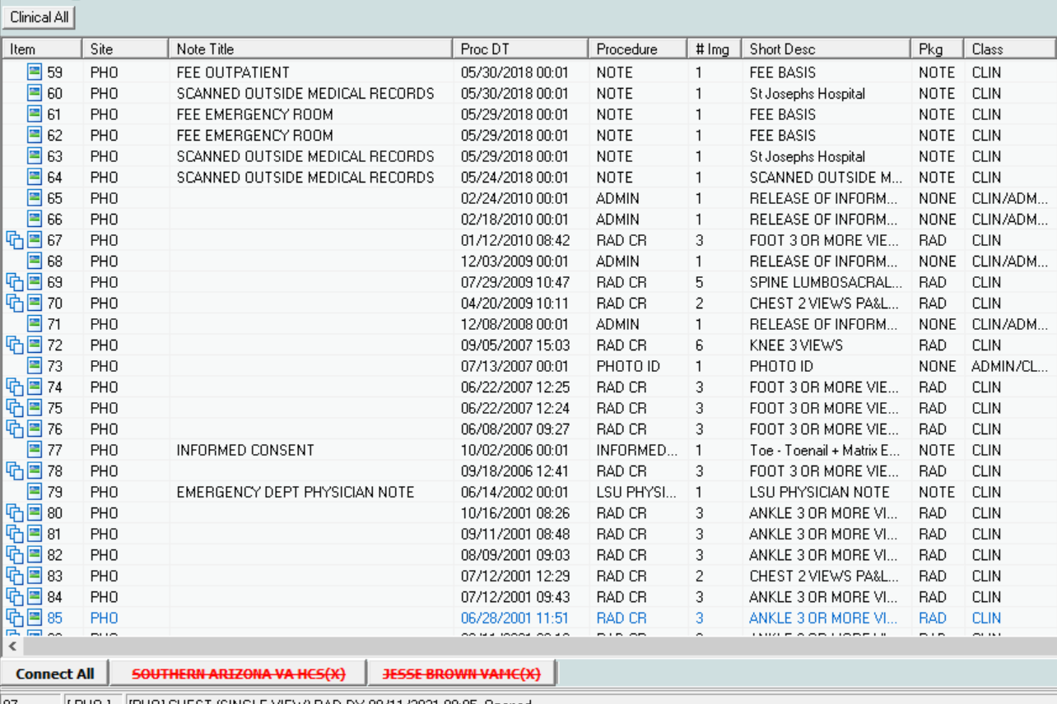
You can click Connect All to link to all the options or you can click on the specific VA to access that site only. The sites will turn green when accessed. If there are any scanned documents or images from the remote sites, then you will now see these in the same list with images and documents from the Phoenix VA.
