Hematology Test
September 30, 2025

Name: ___________________________

- A 58-year-old man is evaluated for possible smoldering myeloma. Medical history is unremarkable, and he takes no medications.

On physical examination, vital signs and other examination findings are normal.

Serum protein electrophoresis and immunofixation show an IgA protein spike of 3.5 g/dL. Bone marrow biopsy reveals 50% clonal plasma cells.

Whole body low-dose CT scan is negative for bone lesions.

Which of the following is the most appropriate imaging test to perform next?

- Bone scan
- Skeletal survey
- Whole-body MRI
- No further testing

2. A 65-year-old woman is evaluated for a 3-day history of pain and swelling in the left leg following a partial colectomy performed 2 weeks ago for recurrent diverticulitis. She reports no chest pain or dyspnea. Family history is significant for a pulmonary embolism in her grandfather. Medical history is otherwise noncontributory, and she takes no medications.

On physical exam, vitals are normal. Swelling of he left lower extremity is present.

Ultrasound of the left leg shows deep venous thrombosis in the femoral vein.

Which of the following is the most appropriate diagnostic test to perform next?

A. Antithrombin III
B. Factor V Leiden
C. Prothrombin G20210A gene variant
D. No further testing

- A 76-year-old man is admitted to the ICU with septic shock caused by a urinary tract infection (UTI). Medical history is significant for benign prostatic hyperplasia, hypertension, and stage G3 chronic kidney disease. Before the UTI he was asymptomatic. Medications are amlodipine and tamsulosin.

On physical examination, temperature is 39.2 C (102.6 F), blood pressure is 80/60 mm Hg, pulse rate is 96/min, and respiration rate is 18/min. Oxygen saturation is 96% breathing ambient air. Cardiopulmonary examination reveals a clear chest and normal heart sounds.

Laboratory studies show a hemoglobin level of 10.8 g/dL, leukocyte count of 18,000/uL, and platelet count of 112,000/uL.

Three liters of intravenous 0.9% saline and broad-spectrum antibiotics are administered. On hospital day 3, the patient is hemodynamically stable and is transferred to the general medical ward.

Repeat hemoglobin is 7.4 g/dL.

Which of the following is the most appropriate treatment of this patient’s anemia?

- Begin recombinant erythropoietin
- Erythrocyte transfusion to a target of 10 g/dL
- Erythrocyte transfusion to a target of 12 g/dL
- No treatment

- A 29-year-old woman is evaluated in the emergency room for epistaxis and bleeding gums that began 3 days ago. Medical history is unremarkable, and she takes no medications.

On physical examination, temperature is 36.7 C (98.0 F), blood pressure is 110/80 mg Hg, pulse rate is 120/min, and respiration rate is 22/min. Dried blood is seen in her nose, and gingival bleeding is noted. No lymphadenopathy or hepatosplenomegaly is present. Petechiae are present on the lower extremities.

Laboratory studies:
Hemoglobin: 8.9 g/dL
Leukocyte count: 14,000/uL
19% neutrophils
3% bands
32% lymphocytes
15% monocytes
31% “atypical cells”
Platelet count: 8000/uL

The prothrombin time, activated partial thromboplastin time, and INR are elevated; fibrinogen level is low, and fibrin degradation products are elevated.

Peripheral smear is shown:

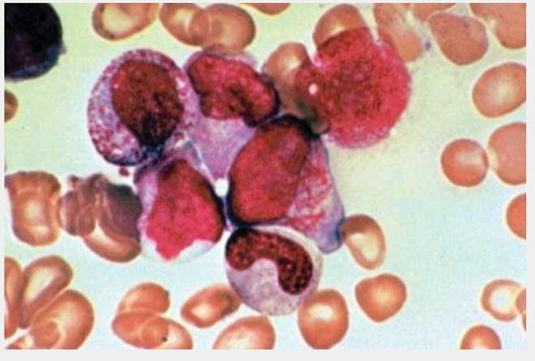

Which of the following is the most likely diagnosis?

- Acute lymphoblastic leukemia
- Acute promyelocytic leukemia
- Aplastic anemia
- Primary myelofibrosis

- A 40-year-old woman is hospitalized with acute shortness of breath. Medical history is significant for two pregnancy losses in the second trimester. Laboratory testing 3 months ago after her second pregnancy loss was positive for lupus anticoagulant, high titer IgG anticardiolipin antibodies, and high titer IgG anti-B2-glycoprotein antibodies. She is otherwise well and takes no medications.

On physical examination, pulse rate is 120/min and respiration rate is 20/min; oxygen saturation is 92% breathing ambient air.

Laboratory studies now show a positive lupus anticoagulant, high-titer IgG anticardiolipin antibodies, and high-titer IgG anti-B2-glycoprotein antibodies.

CT angiography shows a pulmonary embolism in the right main pulmonary artery.

Low-molecular weight heparin is initiated.

Which of the following is the most appropriate long-term treatment?

- Dabigatran plus aspirin
- Rivaroxaban
- Warfarin
- Warfarin plus inferior vena cava filter

- A 25-year-old woman is hospitalized for bleeding 1 day following a tonsillectomy. She reports a history of heavy menses since menarche but no spontaneous bruising or muscle or joint hematomas.
On physical examination, vital signs and examination findings are normal.

Laboratory studies:
Activated partial thromboplastin time (aPTT): 37 sec
aPTT with mixing study: 26 seconds
Hematocrit: 30%
Platelet count: 190,000/uL
Prrothrombin time: 11 sec

Platelet function testing is normal.

Which of the following is the most appropriate diagnostic test to perform next?

- Dilute Russell viper venom time
- Measure factor levels
- Platelet aggregation study
- Von Willebrand antigen assay

- A 49-year-old man is evaluated for progressive fatigue and a 13.6 kg (30 lb.) weight loss in 4 months. Medical history is unremarkable, and he takes no medications.

On physical examination, vital signs are normal. On abdominal palpation, the spleen is enlarged to 17 cm.

Laboratory studies:
Hemoglobin: 11 g/dL
Leukocyte count: 87,500/uL
87% neutrophils
2% bands
2% metamyelocytes
3% myeloblasts
2% basophils
2% lymphocytes
Platelet count: 465,000/uL

Bone marrow biopsy shows hypercellular marrow with granulocytic hyperplasia and 6% myeloblasts. Chromosomal analysis and fluorescence in-situ hybridization studies show t(9;22).

Which of the following is the most appropriate treatment?

- Hydroxyurea
- Imatinib
- Induction chemotherapy
- Stem cell transplantation

- A 68-year-old man is evaluated for a transfusion reaction. He was hospitalized for acute upper gastrointestinal bleeding. While receiving his first unit of packed red blood cells, he developed fever, dyspnea, and flank pain 15 minutes into the transfusion. The transfusion was stopped by nursing staff. His only medication is omeprazole.
On physical examination, temperature is 38.3 C (100.9 F), blood pressure is 80/40 mm Hg, pulse rate is 120/min, and respiration rate is 18/min. Oxygen saturation is 96% breathing ambient air. Cardiopulmonary examination reveals clear lungs, normal heart sounds, and low central venous pressure.

Inspection of a collected urine specimen reveals a pink coloration.

Which of the following is the most likely diagnosis?

- Acute hemolytic transfusion reaction
- Allergic reaction
- Transfusion-associated circulatory overload
- Transfusion-related acute lung injury

- A 48-year-old woman is evaluated for easy bruising. She has no history of gingival bleeding, menorrhagia, or bleeding following procedures. Medical history is notable only for systemic lupus erythematosus. Medications are prednisone, hydroxychloroquine, and NSAIDS as needed.

On physical examination, vital signs and examination findings are normal.

Laboratory studies show an activated partial thromboplastin time of 38 seconds, platelet count of 190,000/uL, and prothrombin time of 12.5 seconds.

Which of the following is the most appropriate next diagnostic test?

- Factor VII inhibitor titer
- Factor XI level
- Factor XII level
- Mixing study

- A 70-year-old man is hospitalized with a 3-day history of acute abdominal pain, nausea, and vomiting. Medical and family histories are non-contributory, and he takes no medications.

On physical examination, vital signs are normal. Palpation elicits mild tenderness in the upper abdomen without hepatosplenomegaly or abdominal mass.

Laboratory studies show a hemoglobin on 14.5 g/dL, leukocyte count of 5000/uL, and platelet count of 250,000/uL.

CT of the abdomen with contrast demonstrates an acute portal vein thrombus.

Which of the following is the mmost appropriate additional diagnostic test?

- Antithrombin measurement
- JAK2 tyrosine kinase mutation
- Protein C measurement
- Protein S measurement

- A 73-year-old man is evaluated in the hospital for new-onset thrombocytopenia. He was hospitalized 48 hours ago for management of CT-angiography confirmed pulmonary embolism. Medical history is significant for coronary artery bypass graft surgery 3 weeks ago. Medications are aspirin, clopidogrel, metoprolol, lisinopril, furosemide, and atorvastatin. Low-molecular weight heparin (LMWH) was initiated on admission to the hospital.

On physical examination, vital signs are normal. Other than a well-healing sternotomy scar, the physical examination is unremarkable.

Laboratory studies:
Hemoglobin: 12 g/dL
Leukocyte count: 11,500/uL
Platelet count: 90,000/uL (at admission 250,000/uL)
Estimated glomerular filtration rate: >60 mL/min/1.73m2

Peripheral blood smear is normal.

The 4T score is 5, corresponding to intermediate risk of heparin-induced thrombocytopenia. LMWH is discontinued, and a test for heparin-induced antibody is ordered.

Which of the following is the most appropriate management?

- Discontinue aspirin and clopidogrel
- Insert an inferior vena cava filter
- Start rivaroxaban
- Start warfarin

- A 30-year-old man is evaluated for progressive fatigue of several months’ duration. Medical history is otherwise unremarkable. He indicates having a sibling. He takes no medications.

On physical examination, pulse rate is 114/min; other vital signs are normal. Oxygen saturation is 98% breathing ambient air. Conjunctival rim pallor and scattered petechiae are noted.

Laboratory studies:
Hemoglobin: 7.1 g/dL
Leukocyte count: 1200/uL
65% neutrophils
35% lymphocytes
Mean corpuscular volume 90 fL
Platelet count: 22,000/uL
Reticulocyte count: 1% of erythrocytes
Peripheral blood smear shows erythrocytes with normal morphology and decreased platelets. A bone marrow biopsy shows marked hypocellularity and increased fat content without dysplastic cells. Testing for viral hepatitis is negative.

The sibling’s test results show an HLA match.

Which of the following is the most effective therapy?

- Allogeneic hematopoietic stem cell transplantation
- Antithymocyte globulin
- Azacytidine
- Intravenous immune globulin

- A 70-year-old man is evaluated for progressive fatigue of several months’ duration. Medical history is significant for carcinoma of the bladder diagnosed 6 years ago, which was treated with combination chemotherapy and radiation, cystectomy, and creation of a urinary diversion pouch with resection of 50 cm of ileum. He takes omeprazole for gastroesophageal reflux disease.

Vital signs and the remainder of the physical examination are noncontributory.

Laboratory studies:
Hemoglobin: 8.8 g/dL
Leukocyte count: 4000/uL
Mean corpuscular volume: 110 fL
Platelet count: 140,000/uL
Reticulocyte count: 1%
Alanine aminotransferase: 30 U/L
Aspartate aminotransferase: 50 U/L
Bilirubin
Total: 3.5 mg/dL
Direct: 0.5 mg/dL
Lactate dehydrogenase: 400 U/L

Peripheral blood smear is shown:

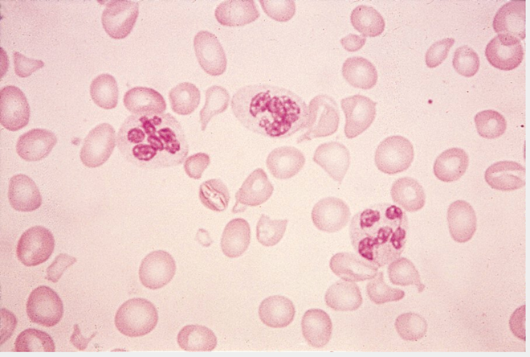

Which of the following is the most likely cause of this patient’s anemia?

- Hypothyroidism
- Immune-mediated hemolytic anemia
- Impaired vitamin B12 absorption
- Liver disease

- A 68-year-old woman is seen in consultation 3 weeks following right hemicolectomy for stage III colon cancer. Medical history is unremarkable, and she takes no medications.

Physical examination is unremarkable, and the surgical site is healing well.

Chemotherapy with 5-fluorouracil, leucovorin, and oxaliplatin is planned.

Which of the following is the most appropriate venous thromboembolism risk management for this patient?

- Calculate the Khorana score
- Initiate apixaban
- Initiate low-molecular weight heparin
- Initiate warfarin

- A 77-year-old man undergoes follow-up evaluation for macrocytic anemia discovered last week on a routine complete blood count. He was diagnosed with polycythemia vera 12 months ago. Treatment consists of the antimetabolite hydroxyurea. Before starting hydroxyurea, vitamin B12 and folate levels were normal. His only other medication is a multivitamin with folic acid.

On physical examination, vital signs and physical examination are normal.

Laboratory studies:
Haptoglobin: Normal
Hemoglobin: 12 g/dL
Leukocyte count: 3000/uL
Mean corpuscular volume: 115 fL
Platelet count: 140,000/uL
Reticulocyte count: 1% of erythrocytes
Bilirubin: Normal
Lactate dehydrogenase: Normal

Peripheral blood smear demonstrates macrocytosis and hyperchromia.

Which of the following is the most likely cause of the patient’s macrocytic anemia?

- Hydroxyurea
- Immune-mediated hemolytic anemia
- Paroxysmal nocturnal hemoglobinuria
- Vitamin B12 deficiency
- A 61-year-old woman is seen in consultation regarding a recently identified monoclonal protein. Medical history is notable for rheumatoid arthritis that has been stable for several years. Her only medication is methotrexate.

On physical examination, vital signs and other examination findings are normal.

Complete blood counts, serum calcium level, and serum creatinine are normal.

Serum protein electrophoresis and immunofixation show an IgG K monoclonal protein spike of 0.8 mg/dL. Serum free light chain and 24-hour urine protein electrophoresis are normal.

Which of the following is the most appropriate management?

- Kidney biopsy
- MRI of the cervical, lumbar, and thoracic spine
- Serum B-2 microglobulin measurement
- Clinical observation

- A 59-year-old woman is evaluated for fatigue, drenching night sweats, low-grade fever, and unintentional weight loss over the past 6 months. She also describes headache, blurry vision, double vision, and difficulty concentrating. Medical history is non-contributory and she takes no medications.

On physical examination, vital signs are normal. Fundoscopic examination reveals dilated retinal veins, flame hemorrhages, and papilledema. Crusted blood is present in the nares. Generalized bulky lymphadenopathy and hepatosplenomegaly are present. Numerous petechiae are noted on the lower extremities.

Serum protein electrophoresis and immunofixation show an IgM K monoclonal protein spike of 6000 mg/dL. Free light chain ratio is > 100. Serum viscosity is pending.

Which of the following is the most appropriate immediate therapy?

- Hydroxyurea
- Intravenous immune globulin
- Plasmapheresis
- Ultrafiltration

- A 36-year-old woman is evaluated for fatigue for 3 months’ duration and dyspnea on exertion of one months’ duration. She is one month postpartum. She takes no medications.

On physical examination, vital signs are normal. Pallor is noted. No scleral icterus is seen. The remainder of the examination is normal.
Laboratory studies:
Hemoglobin: 7.9 g/dL
Leukocyte count: 6800/uL
Mean corpuscular volume: 70 fL (80 fL in first trimester of pregnancy)
Platelet count: 414,000/uL
Red-cell distribution width: Elevated

Peripheral blood smear is shown.

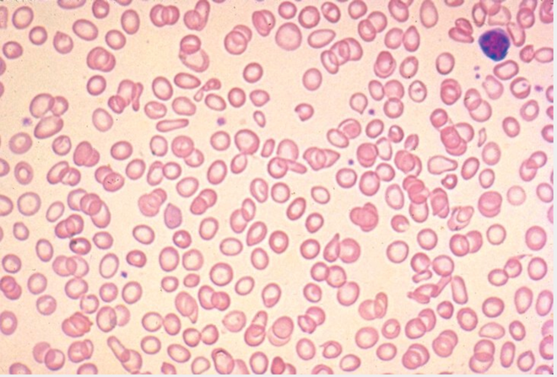

Which of the following is the most appropriate management?

- Colonoscopy
- Oral iron every other day
- Oral iron three times a day
- Hemoglobin electrophoresis

- A 68-year-old woman is evaluated in the emergency department for a 2-day history of melena, with shortness of breath and light-headedness that began today. Medical history. Is significant for atrial fibrillation. Her only medication is warfarin.

On physical examination, blood pressure is 82/50 mm Hg, pulse rate is 126/min, and respiration rate is 20/min. Oxygen saturation is 97% breathing ambient air. Hemorrhage of bright red blood per rectum is observed.

Laboratory studies show a hemoglobin level of 6.2 g/dL and INR of 8.2.

Resuscitation is initiated with intravenous 0.9% saline and erythrocyte transfusions. Intravenous vitamin K is administered.

Which of the following is the most appropriate additional treatment?

- Andexanet alfa
- 4-Factor prothrombin complex concentrate (PCC)
- Idarucizumab
- Protamine sulfate
- A 42-year-old woman is evaluated in the emergency room for a 2-day history of headache, dizziness, and easy bruising. Her medical history is otherwise unremarkable and she takes no medications.

On physical examination, temperature is 38.0 C (100.4 F), blood pressure is 150/98 mm Hg, pulse rate is 104/min, and respiration rate is 16/min. A neurologic examination is normal. She has no lymphadenopathy or organomegaly. Petechiae are noted on both legs.

Laboratory studies:
Haptoglobin: Undetectable
Hemoglobin: 8.2 g/dL
Leukocyte count: 10,200/uL
Platelet count: 8000/uL
Reticulocyte count: 5% of erythrocytes
Creatinine: 1.1 mg/dL

Peripheral blood smear is shown.

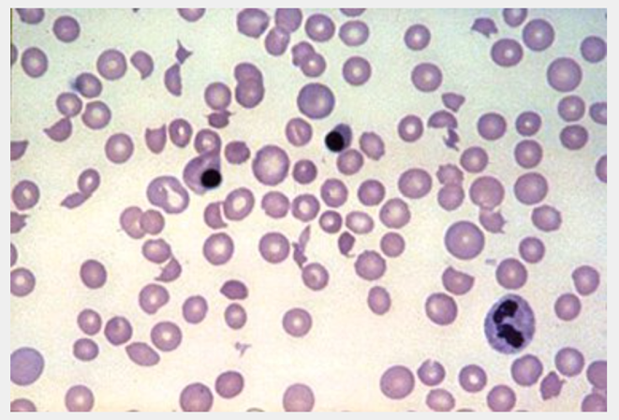

Which of the following is the most appropriate treatment?

- Caplacizumab
- Intravenous nitroprusside
- Plasma exchange with FFP
- Platelet transfusion
- Plasma exchange with 5% albumin

