- ****This may not work if your Android is not encrypted (most newer Anrdoids are by default like Samsung/Pixel/LG). This requires a password (or fingerprint) lock on your phone.****
  - If your phone is not encrypted and you do not want to manually encrypt it, you must purchase Touchdown by Nitrodesk free trial through the Google Play Store (it is $20 after 30 day trial).
  - Please refer to the end of the document for those instructions.

- Submit a request (https://svcnowprod.service-now.com/sp/) using Request Center from a Banner computer to have your email account enabled.
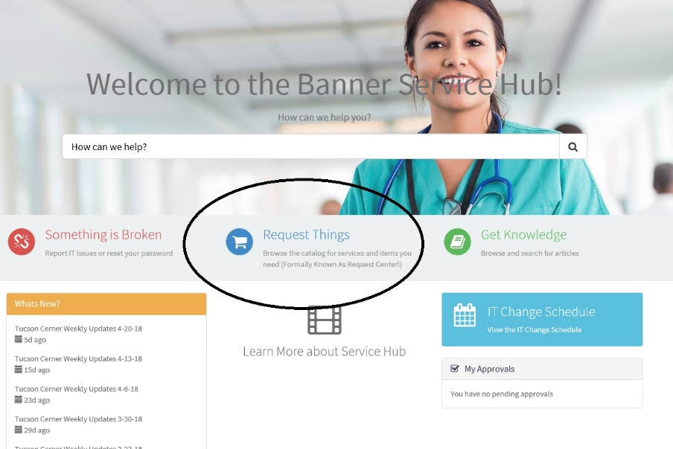
  - Click on Request things

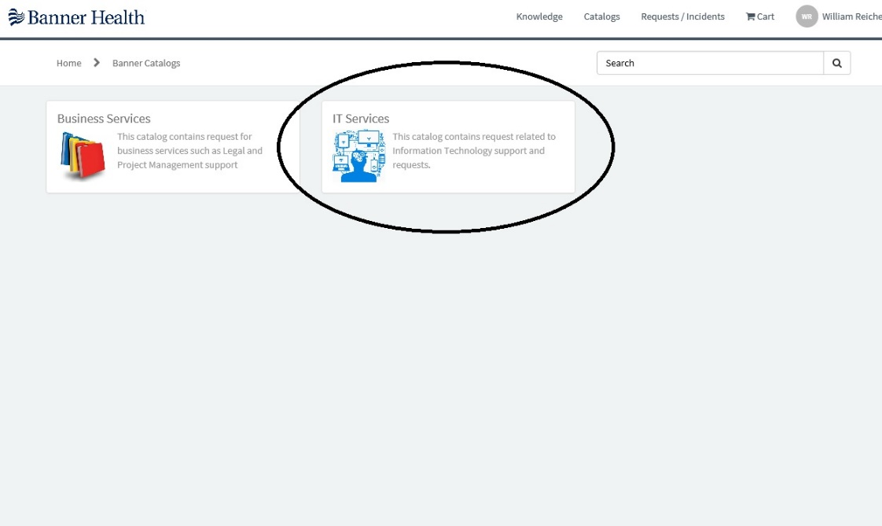
  - Click on IT Services.

  - Click on Communications & Collaboration
    - Then Email
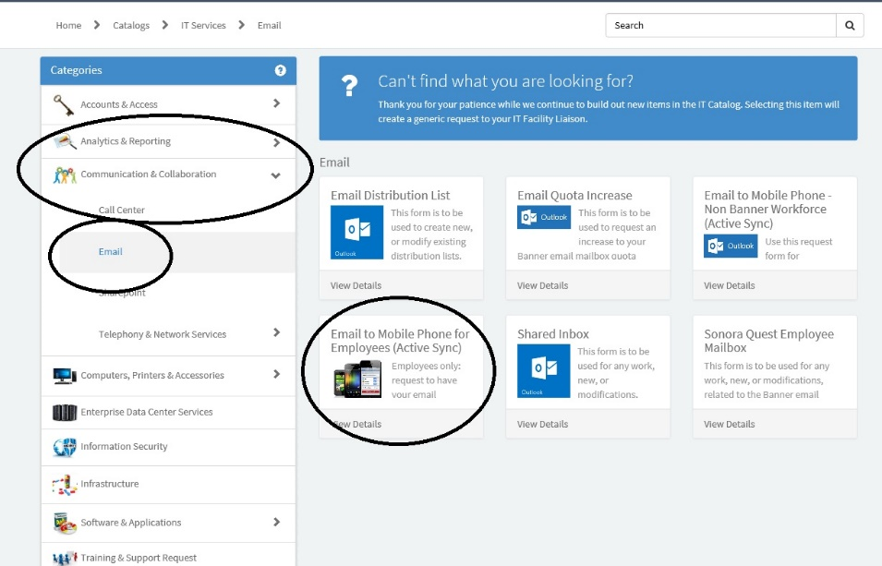
    - Then Email to mobile phone for employees (Active Sync)

  - Fill out the form and submit
  - You will receive (on the Banner email) a message stating you can start to configure your phone after 24 hours

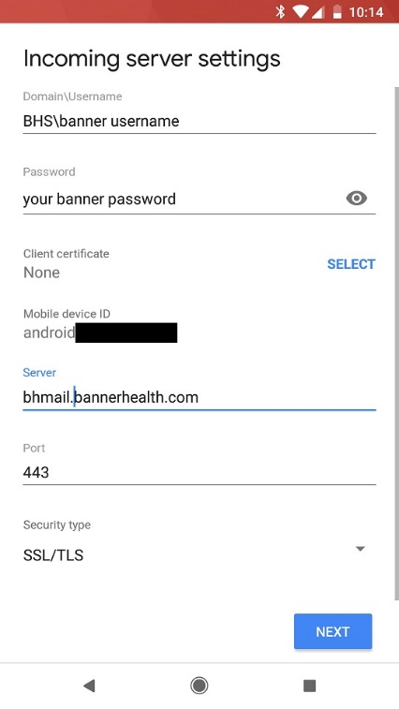
- Configure your phone (these instructions are for the Gmail app but any email app that supports Microsoft Exchange should work).
  - Go into the Gmail app, go into settings and click on add account
  - Click on Exchange/Office 365
  - Enter your Banner Email address (First.Last@bannerhealth.com)
  - Enter your Banner password and click next
  - Domain\Username: BHS\banner username
  - Password: banner password
  - Server: bhmail.bannerhealth.com
  - Port: Leave default (if not working try 443)
  - Security Type: SSL/TLS

- Other app settings after email is set up
  - In general, it is best to sync only email and not contacts to avoid adding every contact in Banner to your phone
  - Under Sync frequency, select push if you want mail to come in as it arrives (uses more battery)

- Once the account is set up, you will get another email stating that your account is placed in quarantine. Make sure to read all the directions but basically it asks you to forward that email (from your banner email and not on your phone) to MobileDeviceActivation@bannerhealth.com to confirm it was you that set up the account. Your account should be activated in one working day.

Instructions for non-encrypted phones using Touchdown by Nitrodesk
****Remember, this is a $20 app (after the 30-day trial) for phones that cannot (or you do not want to) be encrypted. ****
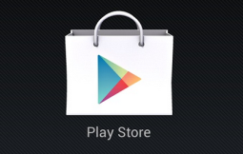
To Purchase and Install Touchdown:
- Launch Google Play Store from the device and search “NitroDesk Touchdown”

- Locate TouchDown for Smart Phones [for Android version 2.x] or TouchDown HD [for Android version 3.x or 4.x] to download the trial version.

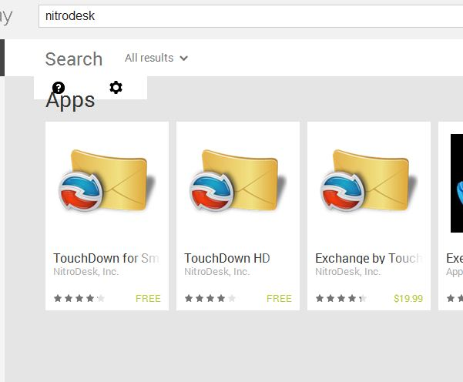
NOTE: Exchange by TouchDown is the license key, do not purchase the key initially. TouchDown for Smart Phones or TouchDown HD is available for a 30 day free evaluation. The KEY purchase is NON-REFUNDABLE, so please make sure you have installed and successfully run the trial version before purchasing the licensing KEY.

- Please make sure that your phone is set to Allow Install from Unknown Sources. This is usually found in your security settings.

- Select the application needed and press Install (following normal Android install processes).
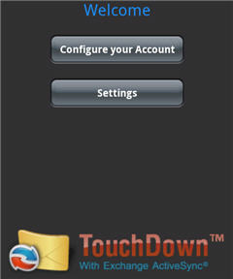
To Configure the Application Settings:

- From the welcome screen, select Configure Your Account
- Enter Account Information
Email: UserFirst.LastName@bannerhealth.com
Password: <computer login password>
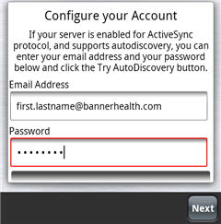
- Select Next

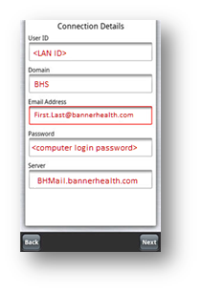
- Enter Connection Details:
User ID: <Your Windows username>
Domain: BHS
Email Address: <UserFirst.LastName@bannerhealth.com>
Password = <computer login password>
Server = bhmail.bannerhealth.com
- Select Next

- Uses secure connections (SSL): Checked
Server certificate verification: Autodetect
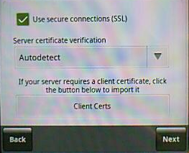
DO NOT HIT THE CLIENT CERTS BUTTON

- Select Next
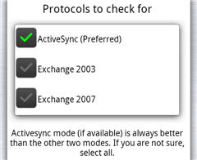
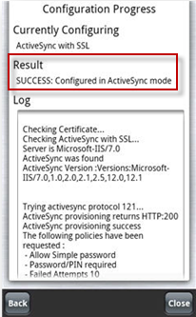
- Protocols to check for:
ActiveSync (Preferred) = checked
Exchange 2003 = unchecked
Exchange 2007 = unchecked
- Select Next

- Select Next again

Configuration Progress:
Result = SUCCESS: Configured in ActiveSync mode

- Select Close

- Create a Passcode for Touchdown
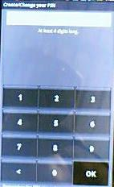

- *This is enforced by Banner Health as a security measure

For additional Settings and Configurations, please refer to http://www.nitrodesk.com

