November 11, 2025, AHD MKSAP Questions
1. A 77-year-old woman is evaluated for a 2-month history of shortness of breath and lower extremity edema. She has a history of hypertension and non-ischemic cardiomyopathy with a left ventricular ejection fraction (LVEF) of 45%. She is receiving guideline-directed medical therapy for heart failure with valsartan-sacubitril, empagliflozin, spironolactone, furosemide, and metoprolol succinate.

On physical examination, blood pressure is 90/65 mm Hg, pulse rate is 60/min, and oxygen saturation is 95% breathing room air. Central venous pressure is elevated. Cardiopulmonary examination reveals crackles at both lung bases; an irregular rhythm; a holosystolic murmur heard best at the apex, radiating to the back; and a loud S2. Moderate edema is noted in both lower extremities.

ECG shows nonspecific T-wave abnormalities with a ventricular rate of 70/min. Chest radiograph shows mild pulmonary edema and a dilated cardiac silhouette. Transthoracic echocardiogram shows a dilated ventricular diameter of 6.2 cm, an LVEF of 48%, and moderate posteriorly directed mitral regurgitation.

Which of the following is the most appropriate next step in management?

A. Coronary angiography
B. Transcatheter mitral valve repair
C. Transesphageal echocardiography
D. Treadmill stress testing

2. A 27-year-old woman is evaluated for progressive dyspnea and fatigue. She first noted shortness of breath walking up a hill about 2 years ago. The dyspnea has progressed, and now she notices it walking even short distances. She has not had chest pain, orthopnea, or other symptoms. She has asthma and uses a glucocorticoid/bronchodilator inhaler as needed.

On physical examination, blood pressure is normal and pulse rate is 80/min. Estimated central venous pressure is normal. The lungs are clear. Cardiac examination reveals an opening snap and a diastolic rumble heard best at the cardiac apex. Mild lower extremity edema is noted.

Transthoracic echocardiogram shows normal size and function of the left and right ventricles. The mitral valve is thickened with restricted opening; mitral gradient and calculated valve area show moderate mitral stenosis.

Which of the following is the most appropriate management?

A. Cardiac magnetic resonance imaging
B. Exercise echocardiography
C. Percutaneous balloon mitral commissurotomy
D. Repeat echocardiogram in one year

3. A 22-year-old woman comes to the office to discuss plans to become pregnant. She has a 5-year history of dyspnea while climbing one flight of stairs, which has not worsened. She occasionally awakes at night short of breath and has to sit up to breathe. She had rheumatic fever at age 8 years and has resultant mitral stenosis. She has a hormonal intrauterine device and takes penicillin VK for secondary prevention of rheumatic fever.

On physical examination, vital signs are normal. Central venous pressure is elevated. A grade 2/6 diastolic rumble is heard at the left lower sternal border.

Routine laboratory results are normal.

ECG reveals left atrial enlargement. Echocardiogram shows a thickened mitral valve with restricted opening and severe mitral stenosis, with a mean gradient of 16 mm Hg; mild mitral regurgitation; mildly elevated right ventricular systolic pressure; and no RV hypertrophy.

Which of the following is the most appropriate management for this patient regarding pregnancy?

A. Counsel against pregnancy at this time
B. Exercise stress testing
C. Proceed with pregnancy
D. Transesophageal echocardiography

4. A 68-year-old man is evaluated for a several-month history of intermittent symptomatic palpitations. He has type 2 diabetes mellitus. ECG is shown.

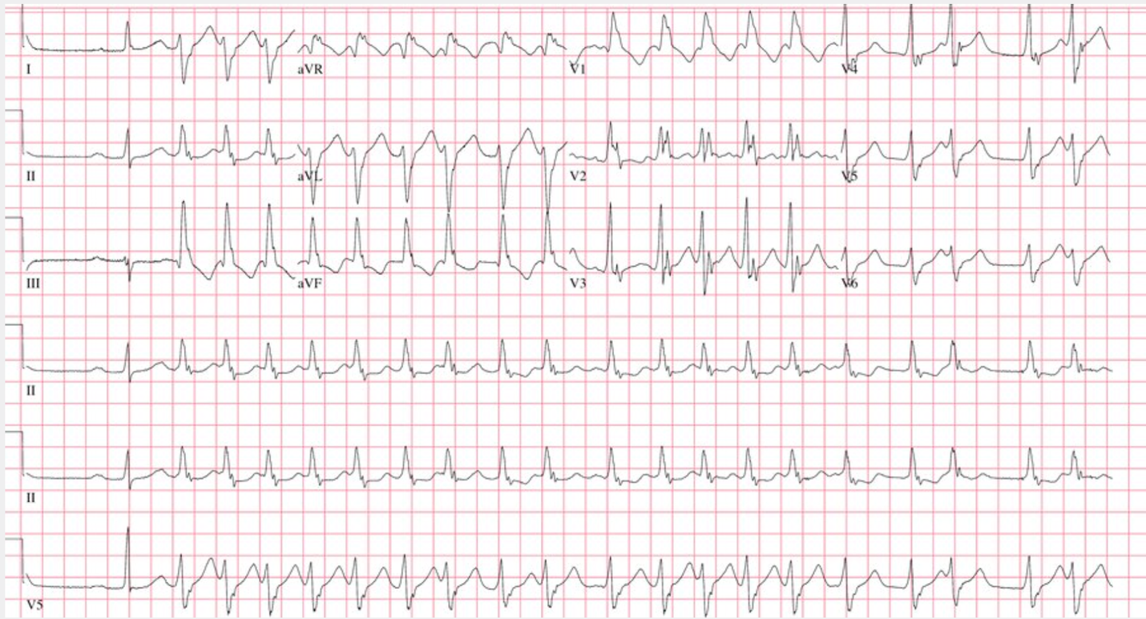

Which of the following is the most likely diagnosis?

A. Antidromic atrioventricular reciprocating tachycardia
B. Atrial fibrillation with aberrant conduction
C. Multifocal premature ventricular contractions
D. Ventricular tachycardia

5. A 58-year-old man is evaluated in an urgent care center for symptoms of presyncope. Blood pressure is 89/51 mm Hg, and pulse rate is 127/min. ECG is shown.

Which of the following is the most likely diagnosis?

A. Atrial fibrillation
B. Atrial flutter
C. Right bundle branch block
D. Ventricular tachycardia

