Linking PIV Badge for Easier Signing On

- Close all open applications and internet browser windows.
- Open Internet Explorer and navigate to the IAM Provisioning Service Link VistA to User task.
- If you are not already logged into a Single Sign-On (SSO) application, the site will prompt you to log in.
  - Click the PIV card.
  - Select your certificate
(Certificate should read Issuer: Veterans Affairs User CA B1.
  - Enter PIN
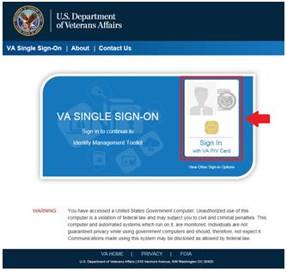
  - If you receive the following errors after logging in, please see the indicated Knowledge Document for resolution, then continue to Step 4 below.
    - Page Cannot Be Displayed: Verify the correct Internet Explorer settings, required by the VA for PIV use (KB0013570).
    - You are in compatibility mode and certain features in the TK will not work as expected: Turn off compatibility view (KB0013476)
- The Link VistA to Usertask window will open. If it does not, click Link VistAUser from the navigationlinks on the left.
NOTE: After selecting Link VistA User, the message: No VistA Stations Linked to your account in Provisioning, will display. This can be ignored.
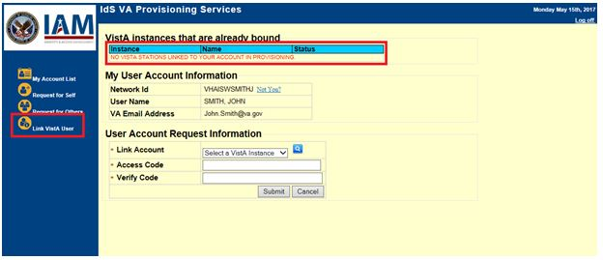
- From the Link Account drop-down menu, select a VistA Instance.
(The VistA Instance list is sorted by station number. If station ends in a letter or contains a letter, select the parent station for your division. For example, if your station is 576A or 576A5, select 576 station number).
Tip: To jump to a station on the list, type the station number. The selection will jump to that spot in the drop-down menu.)
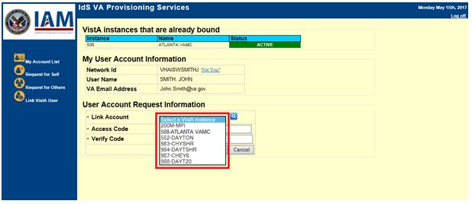
- Enter your VistA/CPRS Access Code and Verify Code for that VistA instance, and then click Submit.
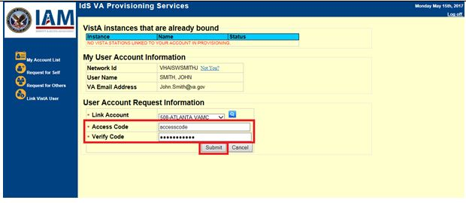
NOTE: Access Code and Verify Code may also be known as VistA or CPRS code, or VistA or CPRS password. It is the same information entered to log into VistA and CPRS.
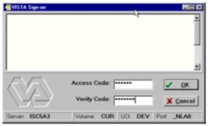
- Once you click submit, if the Access/Verify code was accepted and successful, the application returns the message: Your Provisioning Account and VistA Account have been linked. Your user DUZ is (XXXXX) Linked with Sec ID: XXXXXXXX.
NOTE: There may be a delay before the link is successful. If this happens, the application returns the message: Your request has been staged. You will receive an email once the linkage is complete. You can check back to see if the link is complete. Once the link is complete, you will see the connected instance as shown in the image below (Step 7).
- Verify the newly linked VistA account in the list of Instance Names.
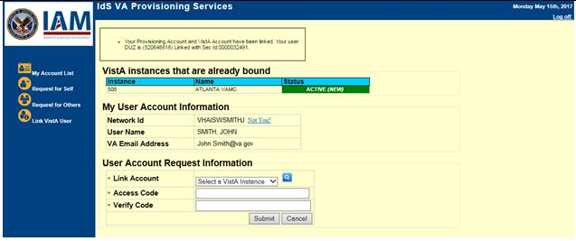
- If you have access to more than one VistA account,repeat steps 5-7 until all VistA accounts have been linked.
- Select Log Off at the top right of the screen to go to the IAM SSOi session page.
- Click Log Out at the bottom of the page to close IAM SSOi session.
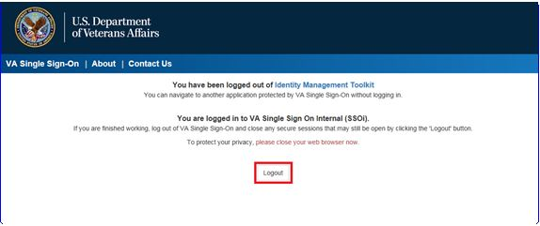
You have successfully linked your PIV credential to your VistA account(s).

NOTE: If you experience any issues or are unable to complete the linking/binding process, contact the Enterprise Service Desk at (855) 673-4357. DO NOT LEAVE A COMMENT FOR TECHNICAL ISSUES.

