Documenting Outside Labs
- Use the Outside Lab note title to document outside labs i.e., COVID tests.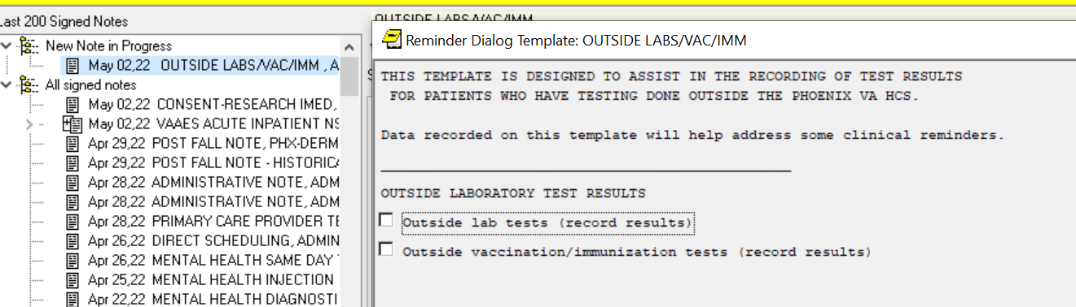
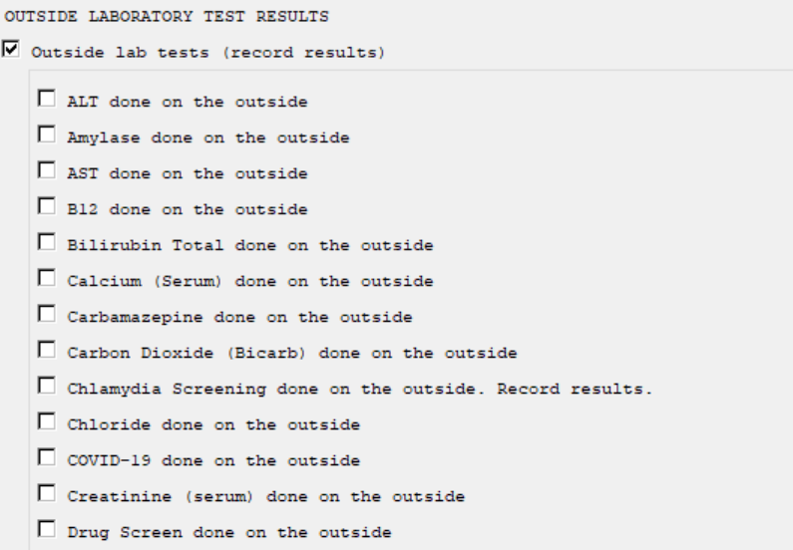
- Insert the details of the lab test and sign the note.
