September 23, 2025, MKSAP

1. A 68-year-old patient is evaluated during a routine follow-up visit for a 1-month history of progressive fatigue. Medical history is significant for hypertension and type 2 diabetes mellitus. Medications are losartan and insulin.

On physical examination, vital signs are normal. Mild pallor is noted, The remainder of the examination is unremarkable.

Laboratory studies:
Hemoglobin 10.5 g/dL
Leukocyte count: 6700/uL
Platelet count: 225,000/uL
Calcium: 9.7 mg/dL
Creatinine: 2.4 mg/dL
Creatinine 1 year ago: 0.9 mg/dL
Hemoglobin A1c: 9.9%
Free kappa light chains: 2000 mg/L (normal 3.3-19.4 mg/L)
Free lambda light chains: 10 mg/L (normal 5.7-26.6 mg/L)
Kappa/lambda free light-chain ratio 200 (normal 0.26 -1.65)
Urinalysis: 3+ protein

Serum protein electrophoresis and immunofixation show an IgG monoclonal protein spike of 1.5 g/dL. Bone marrow biopsy reveals 50% clonal plasma cells without Congo red staining.

Which of the following is the most appropriate diagnostic test to perform next?

A. Abdominal fat pad biopsy
B. Kidney biopsy
C. 99m-Technetium pyrophosphate scintigraphy
D. No further testing

2. A 64-year-old man is evaluated following autologous hematopoietic stem cell transplantation (HSCT) for standard-risk multiple myeloma. He was initially diagnosed 6 months ago, and he achieved complete remission with induction therapy with bortezomib, lenalidomide, and dexamethasone followed by autologous HSCT. He reports fatigue but is otherwise well. He takes no medications.

On physical examination, vital signs are normal.

Laboratory studies, including complete blood count and serum protein electrophoresis, are normal.

Which of the following is the most appropriate management?

A. Maintenance therapy with bortezomib, lenalidomide, and dexamethasone
B. Maintenance therapy with lenalidomide
C. Second autologous HSCT
D. Observation

3. A 52-year-old woman is evaluated during hospitalization for acute onset of thrombocytopenia and deep venous thrombosis (DVT). She was admitted to the hospital 7 days ago after undergoing a total hysterectomy and bilateral salpingo-oopherectomy for ovarian cancer. Following surgery, prophylactic dose enoxaparin and mechanical prophylaxis were initiated. Today, a right lower extremity DVT was diagnosed.

Laboratory studies:
Platelet count: 70,000/uL
Platelet count on admission: 142,000/uL

Which of the following is the most appropriate next step in treatment?

A. Perform platelet transfusion
B. Stop enoxaparin; start apixaban
C. Stop enoxaparin; stsrt warfarin
D. Stop enoxaparin; start unfractionated heparin

4. A 66-year-old man is evaluated for thrombocytopenia. A peripheral blood smear is shown.

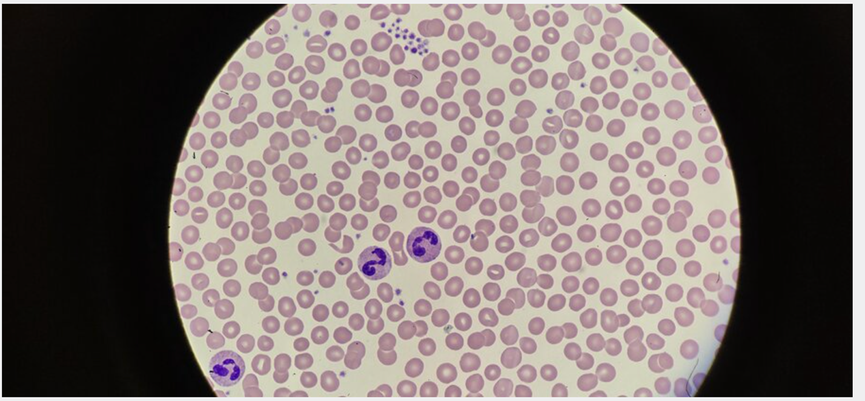

Which of the following is the most likely diagnosis?

A. Evans syndrome
B. Immune thrombocytopenic purpura
C. Pseudothrombocytopenia
D. Thrombotic thrombocytopenic purpura

5. A 35-year-old patient presents for follow-up evaluation for thrombocytopenia that was identified during an emergency department visit following a bicycle accident. They experienced only minor injuries in the accident and have recovered fully. Medical history is unremarkable, and their only medication is acetaminophen as needed for headaches. They take no vitamins or herbal supplements.

Vital signs and other physical examination findings are normal.

Laboratory studies:
Hemoglobin: 15 g/dL
Leukocyte count: 7500/uL with normal differential
Platelet count: 39,000/uL
Reticulocyte count: 1.5% of erythrocytes

A comprehensive medical panel is normal. Antibody testing for hepatitis C virus and HIV is negative.

Peripheral smear shows normochromic, normocytic erythrocytes and normal leukocytes; occasional large platelets are noted.

The laboratory studies are not substantially changed from those noted in the emergency department.

Which of the following is the most appropriate management?

A. Bone marrow biopsy
B. Eltrombopag
C. Intravenous immune globulin
D. Prednisone
E. Observation

