Scheduling Follow-up Appointments After Discharge

- You can see what upcoming appointments a patient is scheduled for by clicking on their name box:
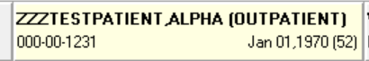

- This window will open and about halfway down you can see a list of any future appointments.
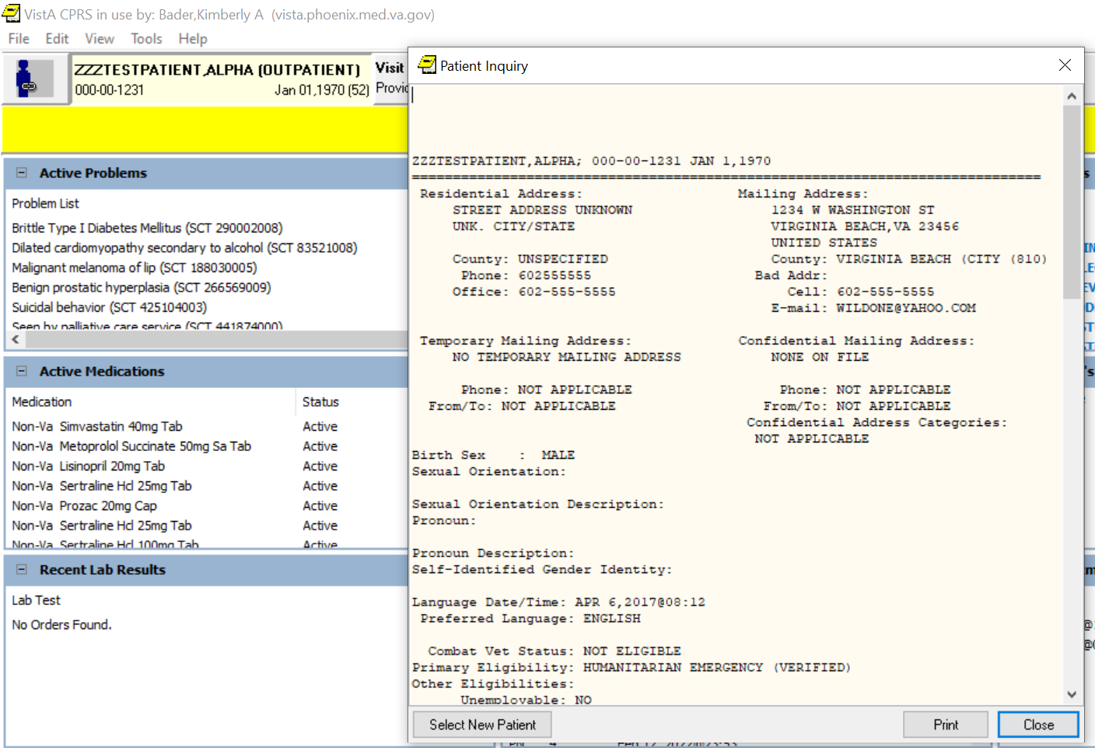

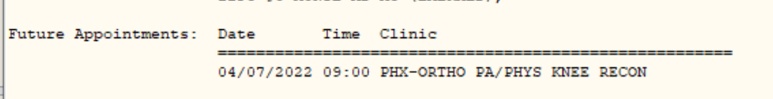

- You can also look on the Cover Sheet tab at the Appointments/Visits/Admissions section on the bottom right.

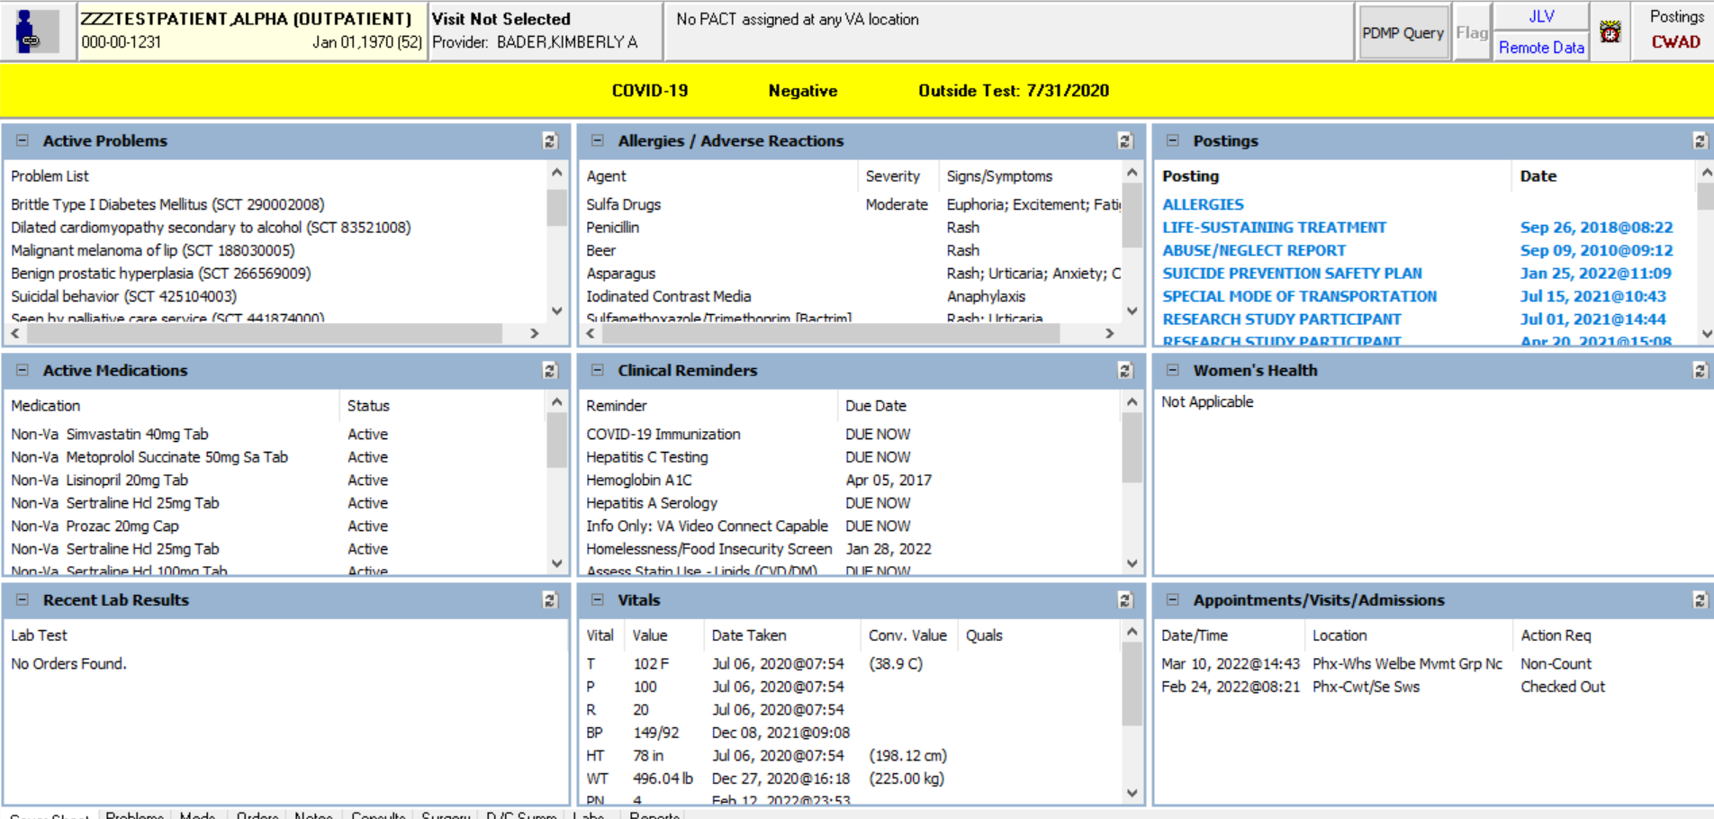

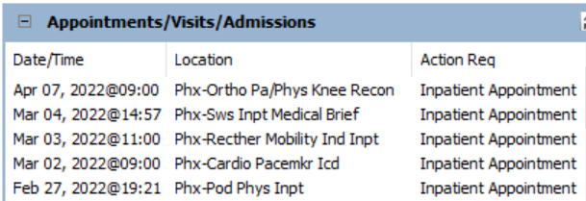

- Some consultants will enter return to clinic orders to set up follow-up for the patients. You can see what appointments are going to be scheduled by looking at the Clinic Scheduling section down at the bottom of the Orders on the Orders tab:

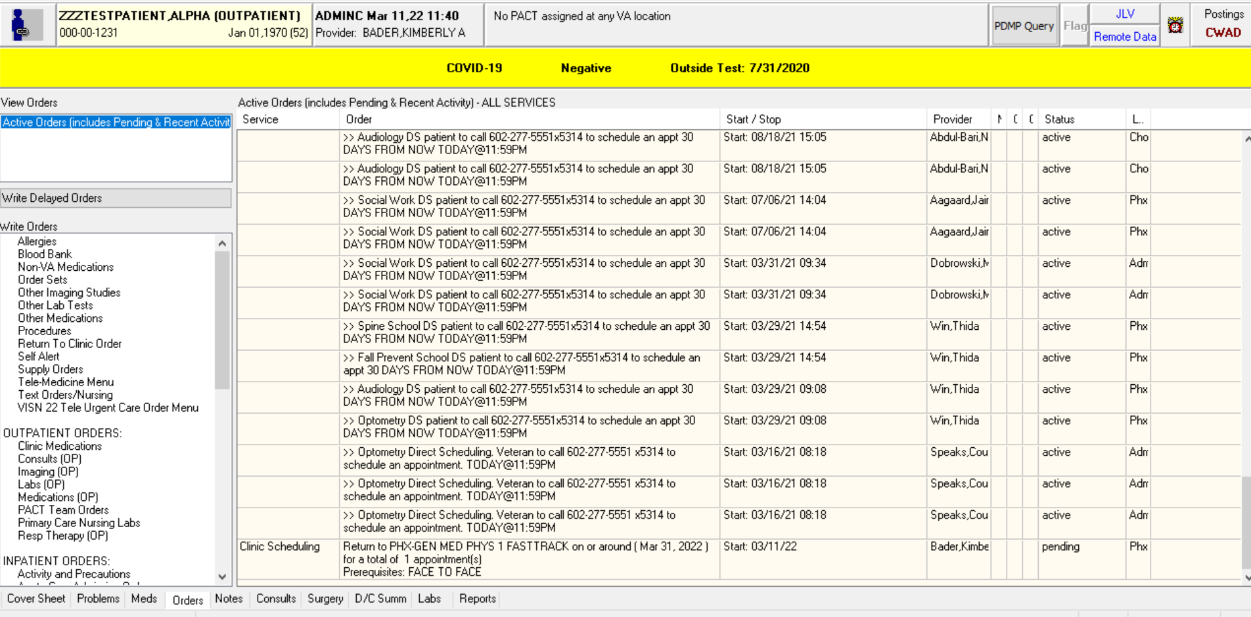

- Some consultants will forward their last notes or place an addendum to their schedulers to set up follow-up. If not, you can reach out to the fellow / resident on the specialty team to see about getting a follow-up appointment booked.

- If the patient hasn’t been seen as an outpatient by the specialty in the last 2-3 years, then you can order an outpatient consult at discharge requesting outpatient follow-up with the specialty.

- If the patient is an existing patient of the specialty, you can provide the clinic extension in your discharge instructions and the patient can schedule their own follow-up appointment. You can find the extensions through the Telephone Directory tool:
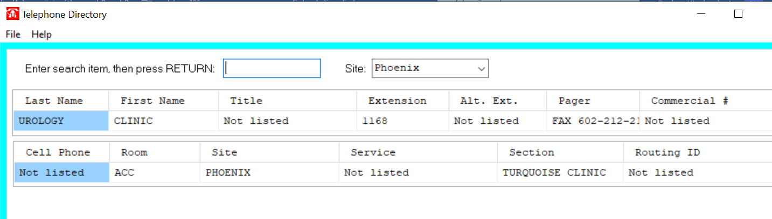

- If the patient doesn’t already have a primary care appointment coming up with their PCP, then when you fill out the discharge instructions you can place a Return to Clinic order for scheduling:
