Academic Half Day – Diabetes
Learner Worksheet
7/16/2023

While you get settled in, fill out the form below matching types of insulin to their duration of action. Also indicate which insulins are appropriate for use as basal vs bolus insulin.

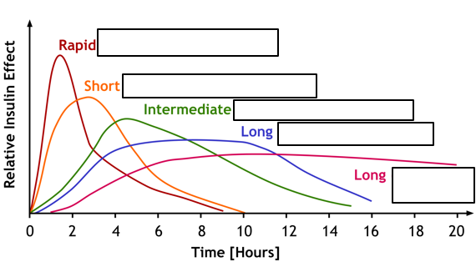

Case 1
Mr. Shugar is a 56yo M who presents to the ED with redness and pain of his left leg for the past 3 days after scraping his ankle accidentally while working on his car. Two days ago, he went to urgent care and received antibiotics. Since then, the redness has worsened despite taking the medication as directed. Yesterday, he developed a fever to 101F, so he decided to come to the ED.

PMHx: Meds:
HTN HCTZ 25mg qd
COPD ASA 81mg qd
Hasn’t been to a doctor in a long time Cephalexin 500mg tid

Social Hx: smokes 1ppd, no EtOH, works as mechanic

Physical Exam:
VS: T 101.4; HR 90; BP 128/76; RR 14; SpO2 97% room air; Wt: 220lb (100kg); BMI 35
GEN: Overall well appearing, no acute distress, obese
CV: Normal S1, S2 with regular rate and rhythm. No murmurs
PULM: Lungs clear to auscultation b/l
EXT: Erythema and warmth of the L lateral lower extremity streaking towards knee. No fluctuance. Tender to palpation only in the area of erythema/warmth. No edema.

ED workup:
Na 135, K 4.2, CL 102, CO2 22, BUN 14, Cr 1.1, glucose 240
WBC 11.2, Hgb 13.2, Hct 39.2, Platelets 354
CRP 4.6, ESR 32

Doppler US: negative for DVT
X-ray Left Tib/Fib: negative for fracture, soft tissue swelling noted

- You notice the patient is hyperglycemic on his renal panel. What other questions would you like to ask him? What factors may contribute to hyperglycemia in this patient?

- Does Mr. Shugar have diabetes? How do you diagnose diabetes?

The patient tells you that he’s never been told he has high blood sugars, but diabetes is prevalent in his family. And now that you mention it, he does urinate pretty frequently. But he reassures you that he drinks tries to stay hydrated and mitigates his thirst by drinking at least 4-5 cans of soda each day.

- What is the next step in the evaluation of his hyperglycemia? What do you include in your inpatient admission orders?

You finish your admission orders, H&P, and start the patient on Vancomycin for cellulitis that did not improve with Keflex. On Hospital day 2, as you pre-chart on Mr. Shugar, you note the following labs:
HbA1c: 8.6
POC glucose: 5pm - 242
9pm - 274
6am - 210

You tell Mr. Shugar that he has likely has diabetes and that you will need to treat his elevated blood sugars. He is anxious and has a lot of questions.

- How do you treat inpatient hyperglycemia? What medications do you use? What do you do next?

- But what if Mr. Shugar was already on metformin 1000mg bid at home for his diabetes and had never been on insulin before?

- Could you use sliding scale insulin as main treatment? What about oral agents since he is insulin-naïve?

- How will you initiate treatment for this insulin-naïve patient? If he weighs 100kg, how much insulin would you start?

- How would your regimen change if Mr. Shugar was on insulin therapy at home?

- What are the goals for glycemic control? Why is this important?

You suspect high insulin resistance based on obesity and elevated a1c and choose to start insulin treatment with TDD of 0.5u/kg in the form of lantus 25u qhs, lispro 8u tid with meals, and a low dose SSI with meals. Unfortunately, Mr. Shugar is reporting worsening pain and swelling of his leg, and you notice progression of the erythema of his leg, with increased induration and new fluctuance. You consult general surgery to evaluate the patient for likely abscess formation. Their note is not in by the time you leave, so you sign this out to cross-cover to follow up surgery recommendations.
Hospital Day 3
You are pre-rounding the next morning when night float tells you that surgery left their recommendations late last night to make the patient NPO for OR today. You quickly review Mr. Shugar’s labs:
6am morning labs today:
Renal panel: Na 140 K 4.0 Cl 105 HCO3 23 BUN 25 Cr 1.4 Glucose 140
CBC: WBC 14.4 Hgb 13.1 Hct 39 PLT 345

POC glucose yesterday: 9am - 245
12pm - 194
5pm – 175
9pm - 153

- Calculate how much insulin the patient received yesterday based on your orders (assume no changes were made to the regimen you ordered because this was not in your sign out). How would you adjust insulin for the next day?

Blood glucose | Low dose SSI  (<40units insulin/day) |  | Medium dose SSI  (40-80units insulin/day) |  | High dose SSI  (>80units insulin/day)
 | AC | HS | AC | HS | AC | HS
100-149 | 0 | 0 | 0 | 0 | 0 | 0
150-199 | 1 | 0 | 1 | 0 | 2 | 0
200-249 | 2 | 1 | 3 | 2 | 4 | 2
250-299 | 3 | 2 | 5 | 3 | 7 | 5
300- 349 | 4 | 3 | 7 | 5 | 10 | 7
>350 | 5 | 4 | 8 | 7 | 12 | 10

You go see Mr. Shugar and notice that he is sitting on the edge of the bed and does not look well. He says he is feeling dizzy and sweaty, which he thinks he may be nerves due to his upcoming procedure. He says he only had a few bites of his lunch because he was put on a special diet and couldn’t order the burger he usually eats for lunch and that he didn’t eat dinner because the surgeons came by and told him not to.
- You check a POC glucose and it reads 60. What are risk factors for hypoglycemia in the hospital setting? How do you manage this?

- What if Mr. Shugar was unresponsive when you found him? What if he lacked IV access?

- How would you have changed his insulin regimen if you knew he was going to be NPO for surgery?

Hospital Day 4
You treated Mr. Shugar’s hypoglycemia appropriately with glucose tabs and he was shortly whisked away to the OR. He underwent successful debridement of his leg abscess and the initial OR wound cultures are growing GPC in clusters.
The following morning, you are pre-charting on Mr. Sugar:
6am labs from this AM:
Renal: Na 133 K 3.9 C: 93 HCO3 18 BUN 25 Cr 1.4 Glucose 459
CBC: WBC 11.2 Hgb 13.7 Hct 39 PLT 345
VBG: pH 7.21 pCO2 33

POC glucose from prior day: 12pm - 172 (immediately post-op)
6pm - 299
12am - 372

You go to see him. He reports the surgery went well and that he was very hungry afterwards so he ate a lot. But this morning he feels poorly. He’s having some nausea and abdominal discomfort. You happen to notice his IV beeping with D5 NS running at 125cc/hr.
- Define the metabolic derangement. What are possible reasons for this?

- How do you know differentiate between DKA vs HHS?
- Review clinical characteristics:

- Review laboratory characteristics:

- What are the 4 key components in the management of DKA?

You initiate therapy with a bolus of 10u regular insulin IV and IVF and contact the senior/nursing supervisor to transfer Mr. Shugar to stepdown level of care to initiate IV insulin infusion. Over the next several hours, the anion gap slowly downtrends to normal. Mr. Shugar also notes starting to feel better, stating that his abdominal pain has resolved and that he is hungry.

- When and how do you transition Mr. Shugar off the insulin infusion?

You resume basal-bolus dosing with Lispro 8u tid with meals and lantus 25u qhs, then turn off the insulin infusion 2 hours later. You make sure to change his POC glucose checks back to qACHS and review the plan with his nurse before leaving for the night.

Hospital Day 5
You’re at the hospital bright and early and eager to pre-round on Mr. Shugar given the activities of the last 24 hours. You hope that Mr. Shugar will have a good day today. His AM labs in the chart:
Renal panel: Na 141 K 3.8 Cl 101 HCO3 24 BUN 16 Cr 1.1 Glucose 220
CBC: WBC 9.2 Hgb 13.9 Hct 39.1 PLT 355

POC glucose 12pm - 156
5pm - 168
9pm - 197

- How do you feel about Mr. Shugar’s glycemic control? What would you adjust, if anything, in his regimen?

- Mr. Shugar tells you he is feeling better and is eager to leave the hospital. What medication(s) do you send him home on? What is the appropriate follow up?

- At his PCP follow-up, you (his new PCP) notice that he has an outside chart you failed to review during admission. It showed he had 2 stents placed for NSTEMI and that he has ischemic cardiomyopathy. Which non-insulin medications should he be started on?

Appendix:
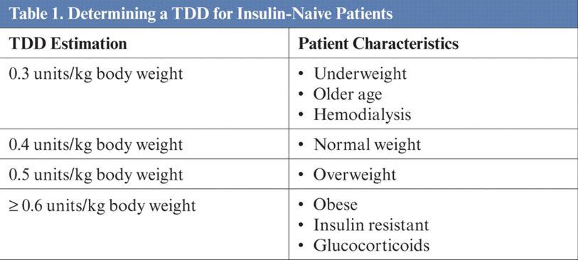
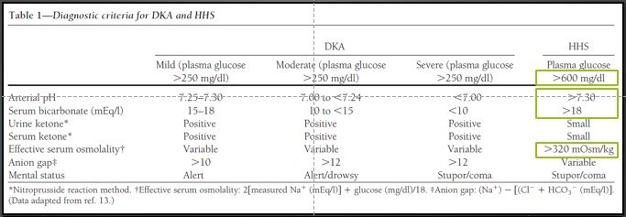
DKA vs HHS management
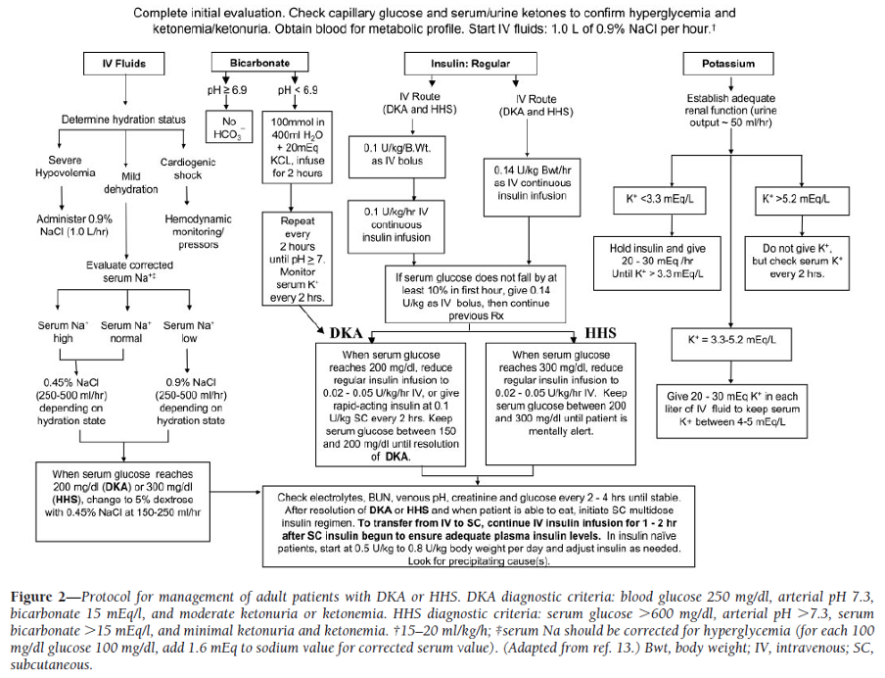

Adapted from University of Cincinnati IM AHD Worksheet. 7/15/2023

