September 8, 2026, AHD MKSAP Questions

1. A 68-year-old patient is evaluated during a routine follow-up visit for a 1-month history of progressive fatigue. Medical history is significant for hypertension and type 2 diabetes mellitus. Medications are losartan and insulin.
On physical examination, vital signs are normal. Mild pallor is noted. The remainder of the examination is unremarkable.
Laboratory studies:
Hemoglobin: 10.5 g/dL
Leukocyte count: 6700/uL
Platelet count: 225,000/uL
Calcium: 9.7 mg/dL
Creatinine: 2.5 mg/dL
1 year ago: 0.9 mg/dL
Hemoglobin A1c: 9.9%
Free kappa light chains: 2000 mg/L (normal 3.3-19.4 mg/L) H
Free lambda light chains: 10 mg/L (normal 5.7-26.6 mg/L)
Kappa/lambda free light-chain ratio: 200 (norma 0.26-1.65) H
Urinalysis: 3+ protein

Serum protein electrophoresis and immunofixation show an IgG monoclonal protein spike of 1.5 g/dL. Bone marrow biopsy reveals 50% clonal plasma cells without Congo red staining.

Echocardiogram is normal with an ejection fraction of 58%. Kidney ultrasound shows no hydronephrosis.

Which of the following is the most appropriate diagnostic test to perform next?

A. Abdominal fat pad biopsy
B. Kidney biopsy
C.99-Technetium pyrophosphate scintigraphy
D. No further testing

2. A 61-year-old man is evaluated in the emergency department for acute-onset, severe midthoracic back pain that developed while he arose from tying his shoes. Medical history is significant for hypertension treated with amlodipine.

On physical examination, vital signs are normal. Pain is exacerbated with percussion over the midthoracic spine.

Laboratory studies:
Hemoglobin: 10 g/dL (L)
Calcium: 11.8 mg/dL (H)
Creatinine: 2.1 mg/dL (H)

A radiograph of the thoracic spine shows a compression fracture at T7 and diffuse demineralization.

Which of the following is the most appropriate diagnostic test to perform next?

A. IgA tissue transglutaminase and total IgA level measurements
B. Serum 1,25-dihydroxyvitamin D measurement
C. Serum protein electrophoresis with immunofixation and free light chains measurements
D. Serum total testosterone measurement
E. 24-hour urine free cortisol measurement

3. A 35-year-old patient presents for follow-up evaluation for thrombocytopenia that was identified during an emergency department visit following a bicycle accident. They experienced only minor injuries in the accident and have recovered fully. Medical history is unremarkable, and their only medication is acetaminophen as needed for headaches. They take no vitamins or herbal supplements.

Vital signs and other physical examination findings are normal.

Laboratory studies:
Hemoglobin 15 g/dL
Leukocyte count: 7500/uL with normal differential
Platelet count: 39,000/uL (L)
Recticulocyte count: 1.5% of erythrocytes

A comprehensive metabolic panel is normal. Antibody testing for hepatitis C virus and HIV is negative.

Peripheral blood smear shows normochromic, normocytic erythrocytes and normal leukocytes; occasional large platelets are noted.

The laboratory studies are not substantially changed from those noted in the emergency department one month ago.

Which of the following is the most appropriate management?

A. Bone marrow biopsy
B. Eltrombopag
C. Intravenous immune globulin
D. Prednisone
E. Observation
4. A 66-year-old man is evaluated for thrombocytopenia. Peripheral blood smear is shown.
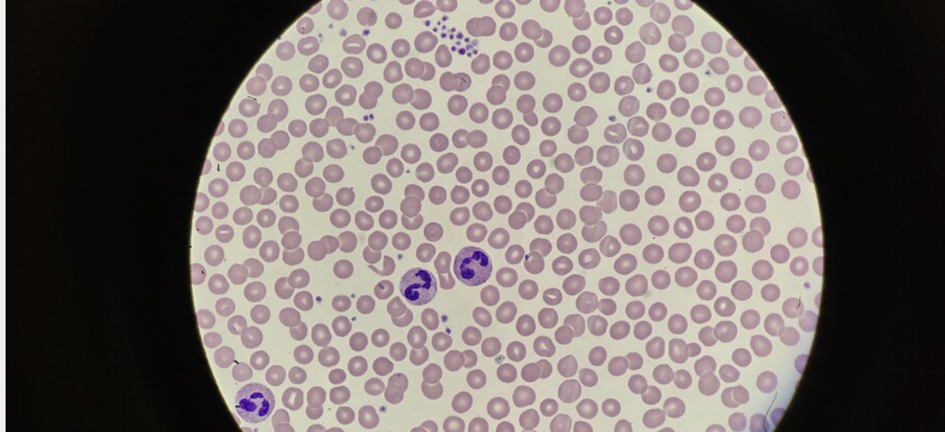
Which of the following is the most likely diagnosis?

A. Evans syndrome
B. Immune thrombocytopenic purpura
C. Pseudothrombocytopenia
D. Thrombotic thrombocytopenic purpura

5. A 52-year-old woman is evaluated during hospitalization for acute onset of thrombocytopenia and deep venous thrombosis. She was admitted to the hospital 7 days ago after undergoing a total hysterectomy and bilateral salpingo-oopherectomy for ovarian cancer. Following surgery, prophylactic-dose enoxaparin and mechanical prophylaxis were initiated. Today, a right lower extremity DVT was diagnosed.

Laboratory studies:
Platelet count: 70,000/uL (L)
On admission: 142,000/uL (L)

Which of the following is the most appropriate next step in treatment?

A. Perform platelet transfusion
B. Stop enoxaparin; start apixaban
C. Stop enoxaparin: start warfarin
D. Stop enoxaparin: start unfractionated heparin

